XAML Layout in Depth & MVVM

Contents

一、 Layout 4

Layout Base Classes 4

Layout Process 4

Demo——Diagonal Panel 对角线Panel 6

Layout Process Internals 8

Dependency Properties与Attached Property 8

Demo——SimpleCanvas Dependecy Property 10

Layout Process Execution——什么时候会调用(Triggered) 11

二、 Layout Properties 13

Alignment 13

Demo——Vertical Stack Panel 13

Width 与 Height 15

Margin 16

Visibility 16

三、 Panels 17

Elements with Children 17

Panel as base Class 17

Grid 19

Demo——FriendViewer 19

Grid Splitter 25

Canvas 26

Stack Panel 27

Wrap Panel 28

Dock Panel 29

四、 Transformations & Projections 30

Transformations 30

控件的Transform Properties 31

Origin of RenderTransform 32

Demo——Rotate Scale Skew Animcation 33

Demo——Translate 35

Demo——FriendViewer Flyout 38

Combine Transformations 41

Projections 41

五、 Advanced Topic 41

Grid as Overlay-Container 42

Grid Shared Size Groups——Pinnable 43

Layout the Content of a Control 46

Change Panel of an ItemsControl 48

ScrollViewer 49

View Box 51

Animated Move in a Panel 52

Demo——New Main Area 54

六、 Styling 57

Styles与Properties 57

Resources——使用Style 58

Extend Style——BasedOn 59

Mixed Style 59

Style.Trigger 59

Animation Trigger 60

ItemContainerStyle 60

七、 Behaviors 61

Behavior Basics 61

Dependency Properties 62

Attached Properties 63

Attached Behaviors with Attached Property 64

Behaviors in Blend 65

八、 Blend Behaviors 66

Behaviors Actions Triggers 66

Demo——Blend Behaviors 66

九、 Animate with Behaviors 69

FluidMoveBehavior 69

MouseDragElementBehavior RemoveElelemtAction 69

TranslateZoomRotateBehavior 69

十、 MVVM In Depth 69

谁创建谁 69

Async in VM 70

Hook up Views and ViewModels——View First 72

VM在Design Time的初始化 73

View First——VM Locator 74

Data Binding 76

View Model First——DataTemplate 76

View VM Communication——Command 78

Input Binding——按键盘与Command 79

View VM Communication——Behaviors Attached Properties 80

View VM Communication——Blend Behaviors 82

View VM Communication——Custom Blend Behavior 83

Hierarchical MVVM——View Switching 84

Data Loading into VM 86

Navigate to Detail 88

Data Source Window Code Generation 90

Edit Nested VM 91

Validation 92

Dependency Injection——解耦和VM与Service 94

Search与Filter 95

# Layout

### Layout Base Classes

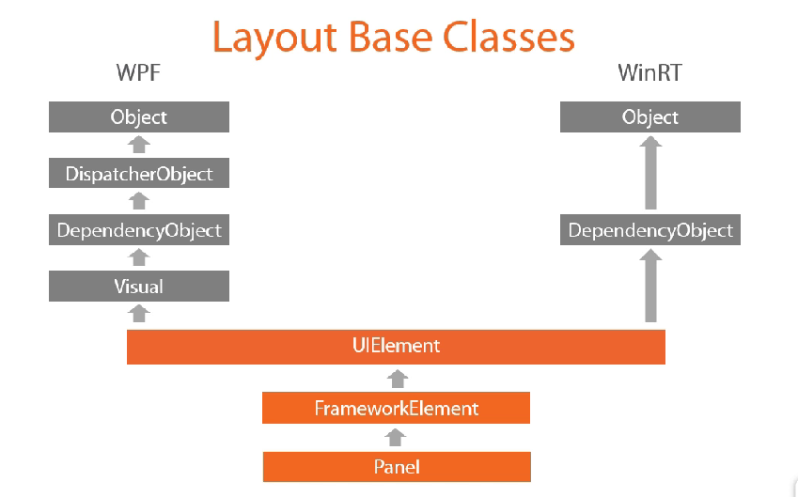

### Layout Process

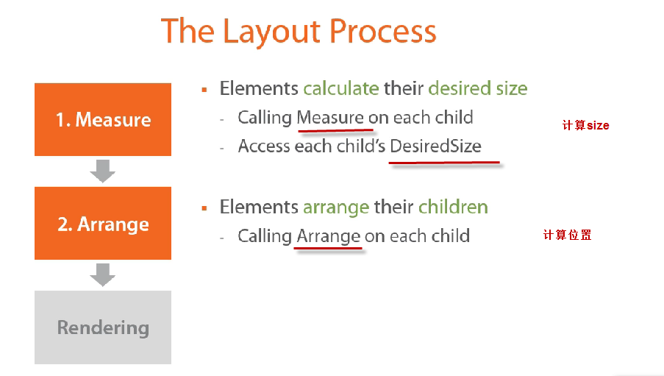

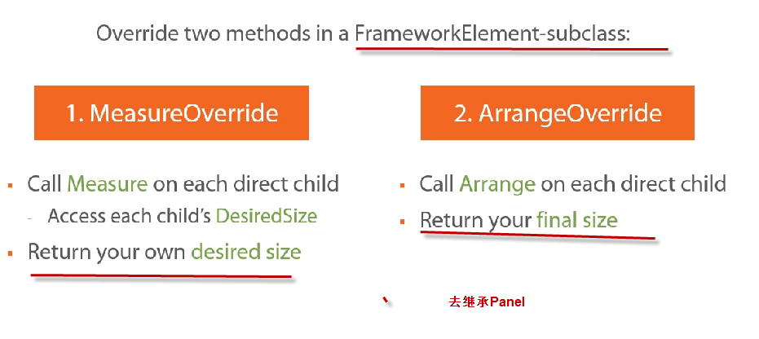

### Demo——Diagonal Panel 对角线Panel

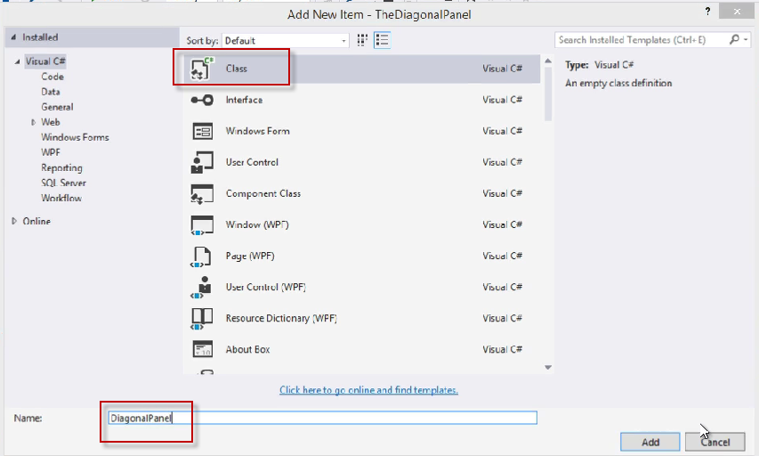

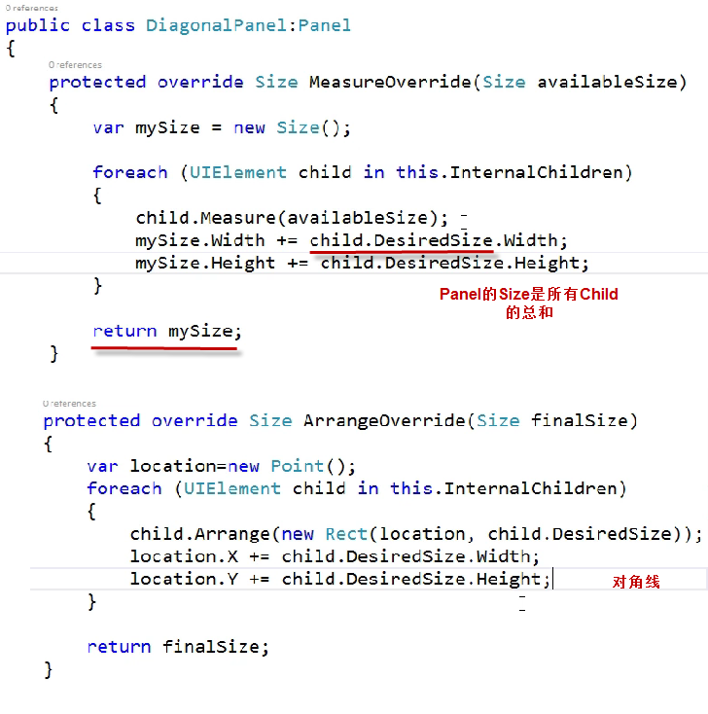

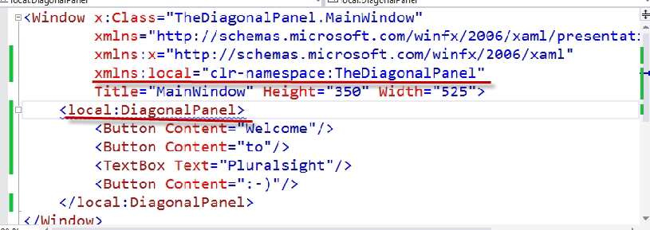

设置Window随Content改变Size

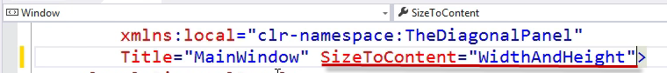

### Layout Process Internals

会自动根据这些东西设置控件的DesiredSize

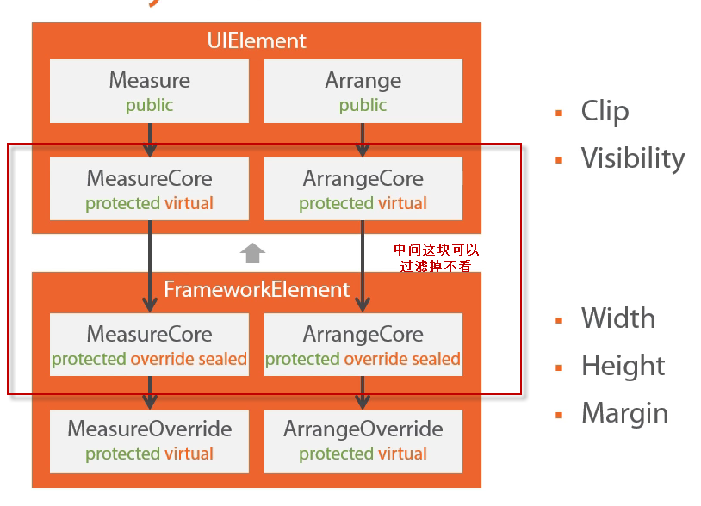

### Dependency Properties与Attached Property

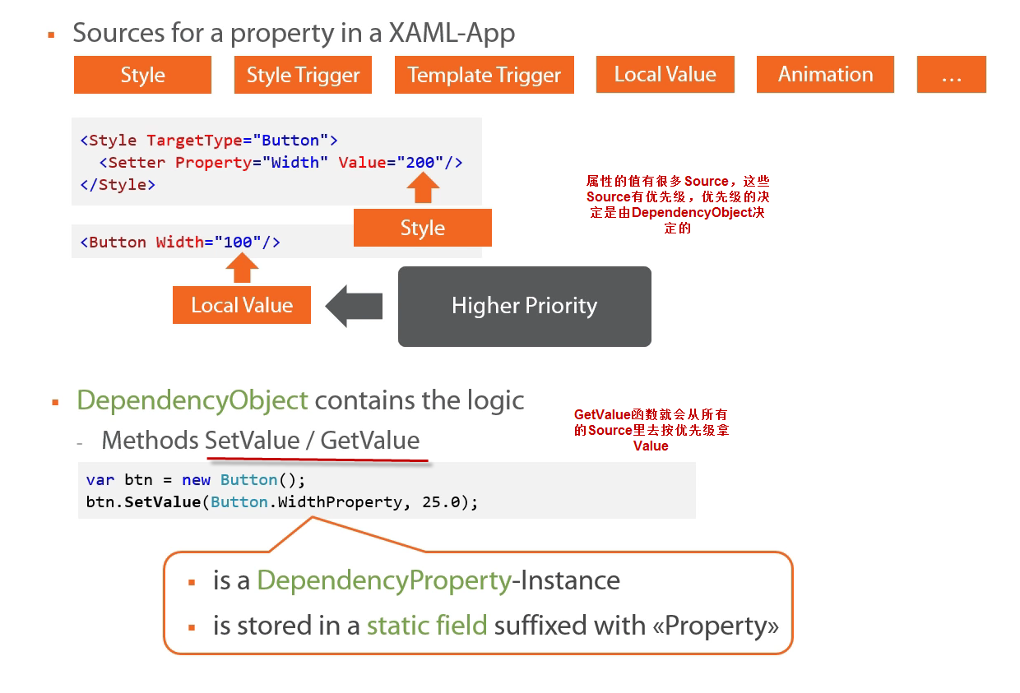

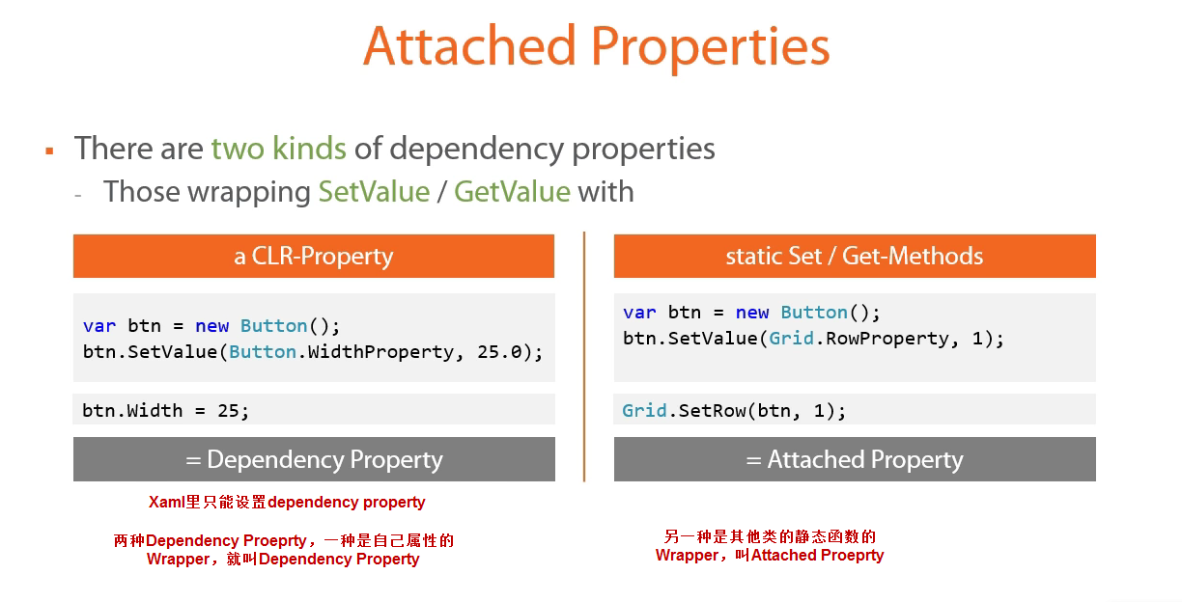

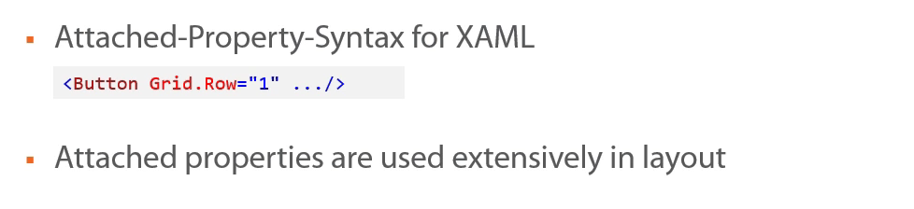

### Demo——SimpleCanvas Dependecy Property

目的是能这么用，其实是个Attached Proeprty

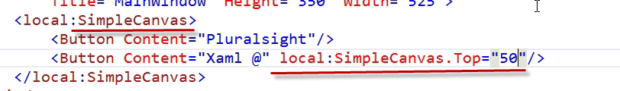

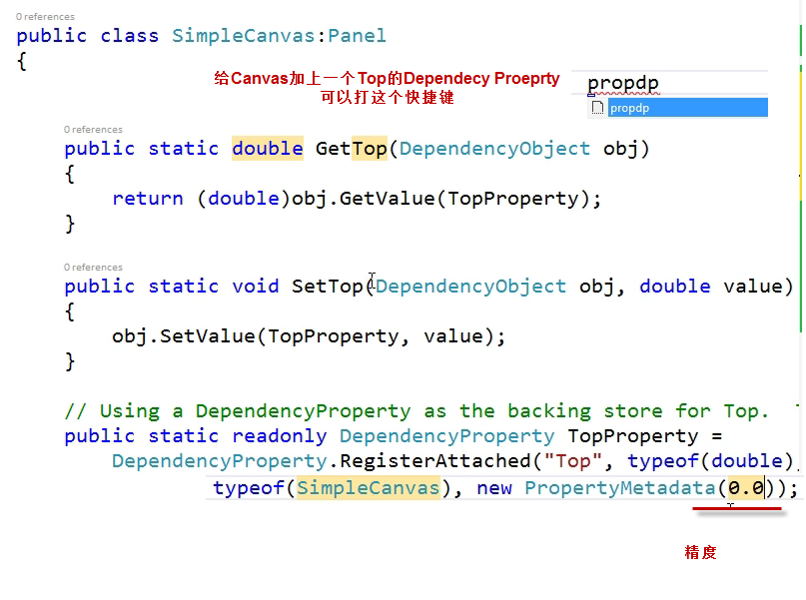

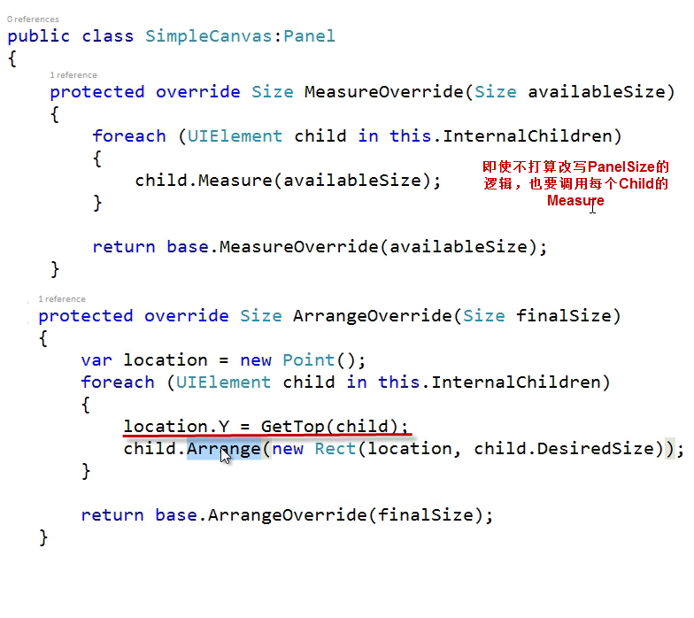

### Layout Process Execution——什么时候会调用(Triggered)

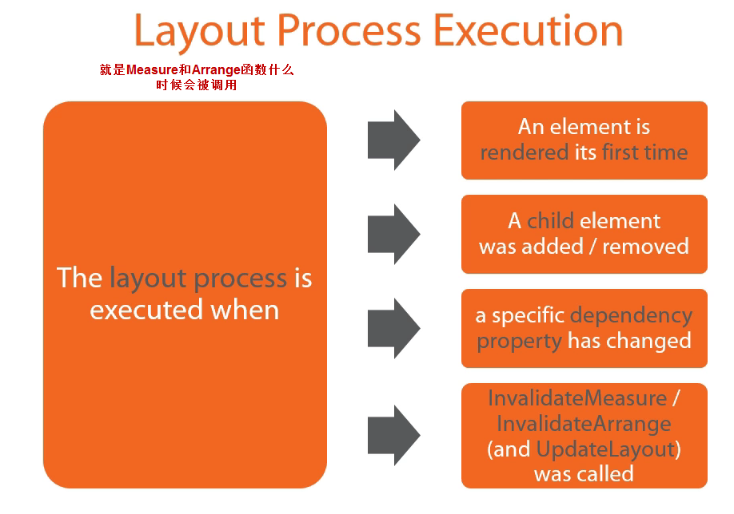

问题是上面做的那个Dependency Property不会引起layout process重新执行，也就是Top改变了以后Panel里的元素不会改变

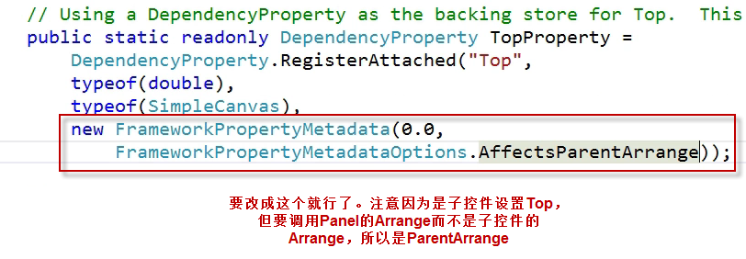

# Layout Properties

### Alignment

**注意，只有当控件的Width > 控件的DesiredSize.Width时才有效**

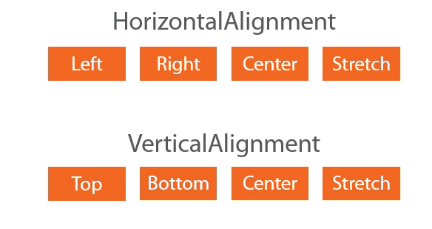

### Demo——Vertical Stack Panel

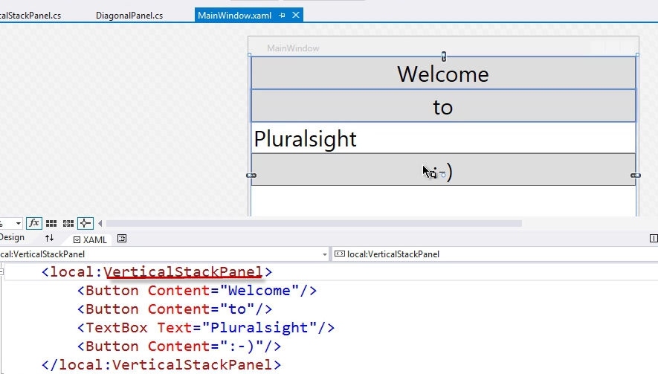

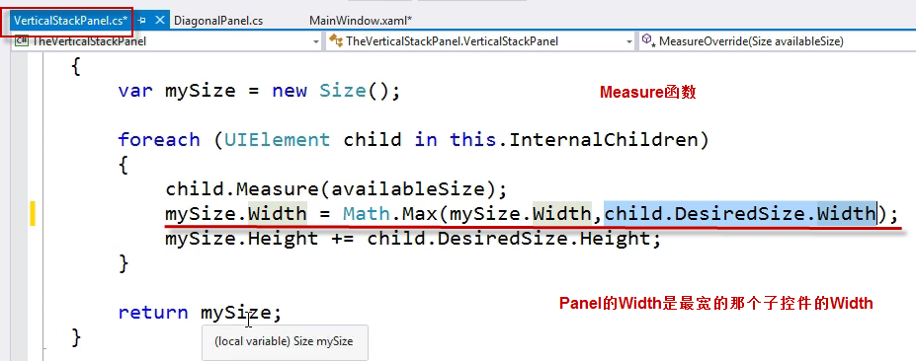

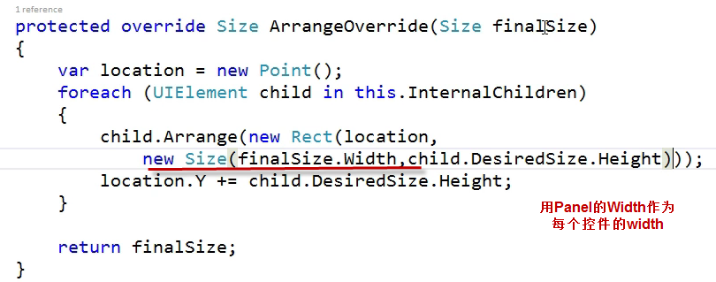

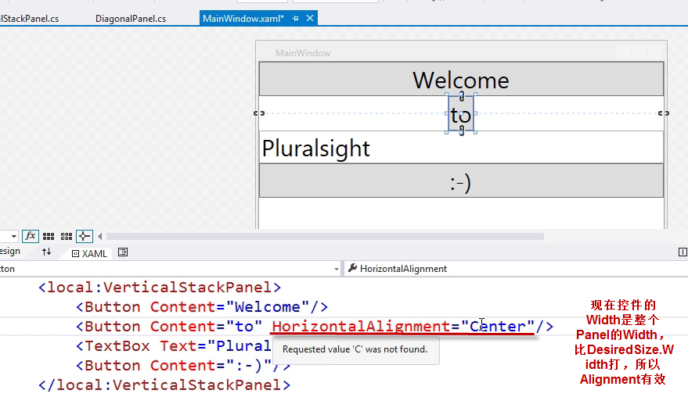

### Width 与 Height

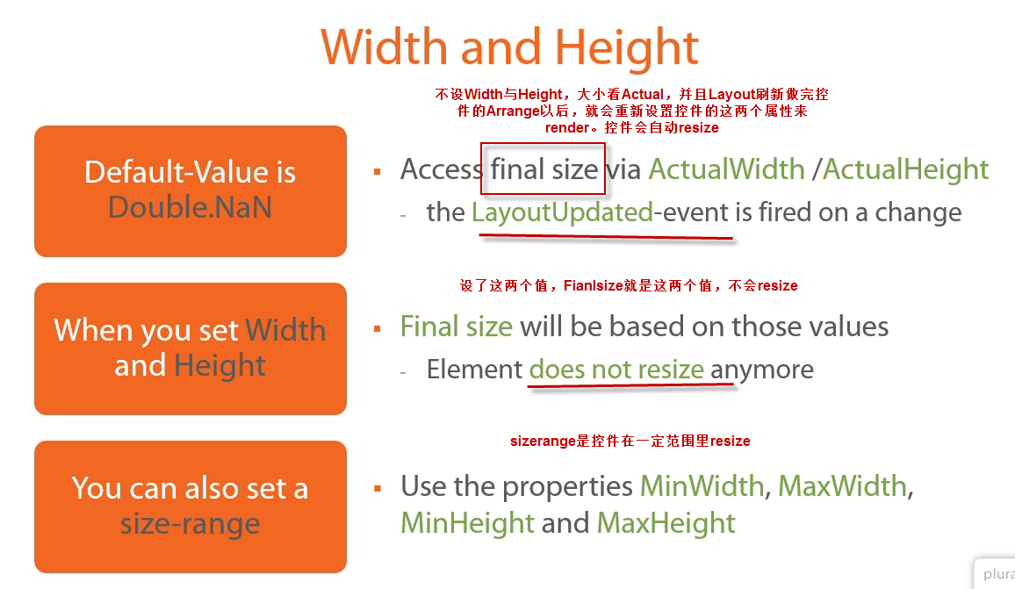

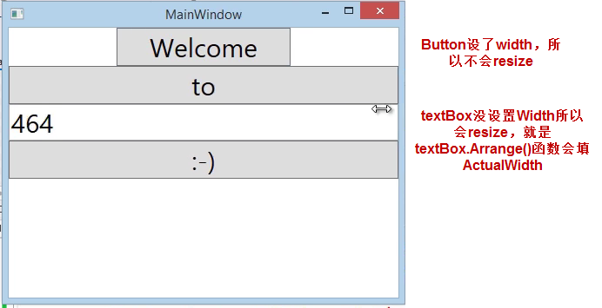

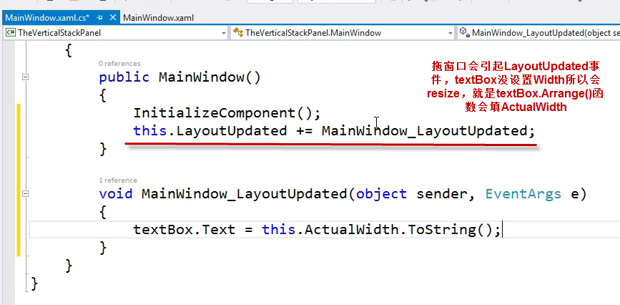

### Margin

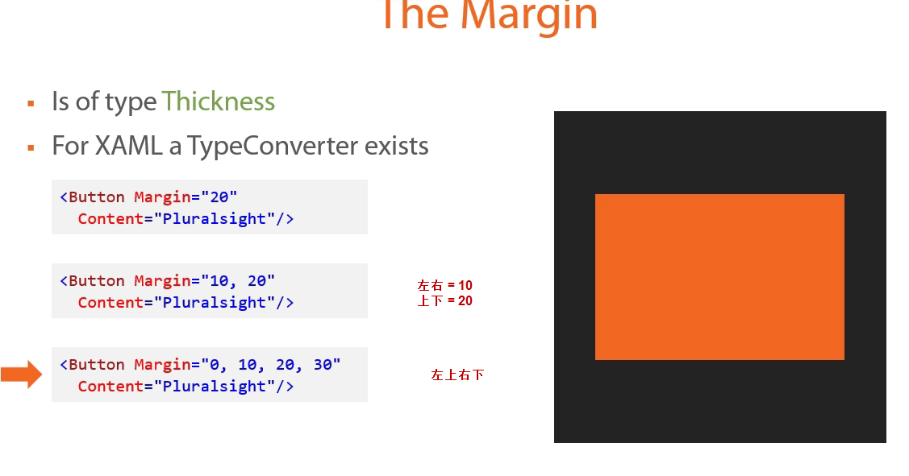

### Visibility

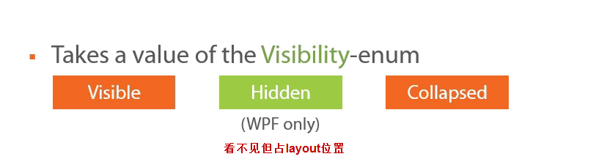

# Panels

### Elements with Children

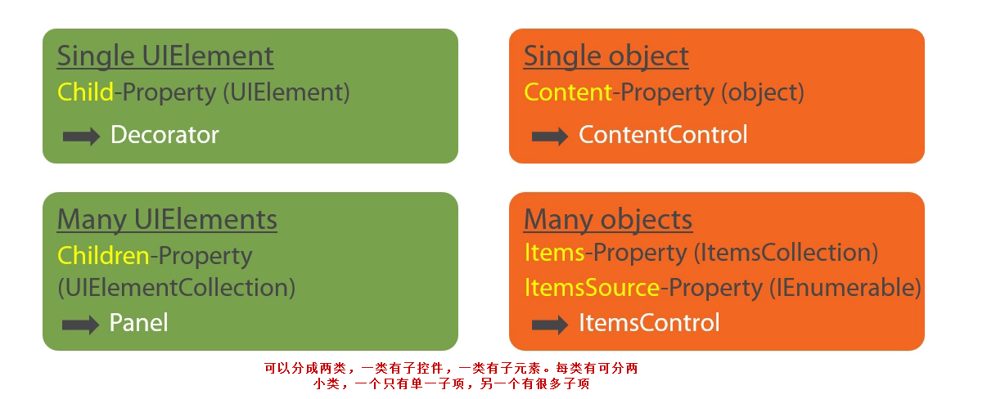

### Panel as base Class

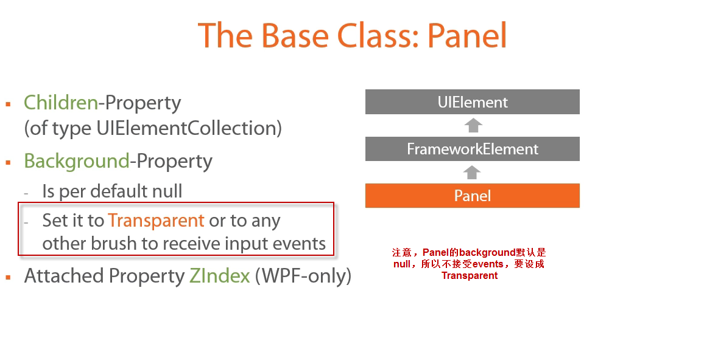

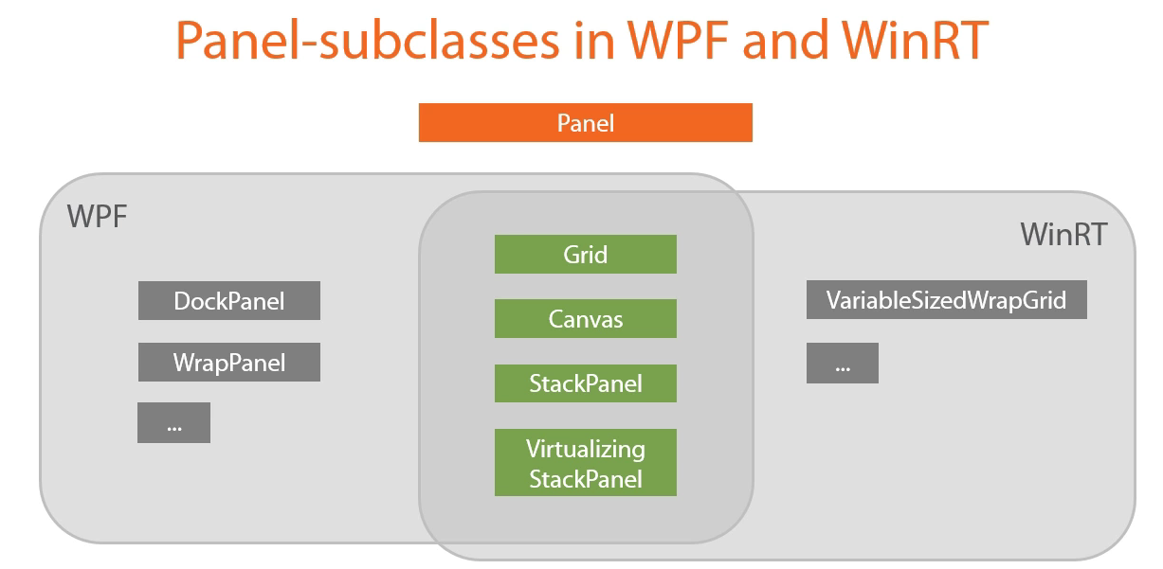

### Grid

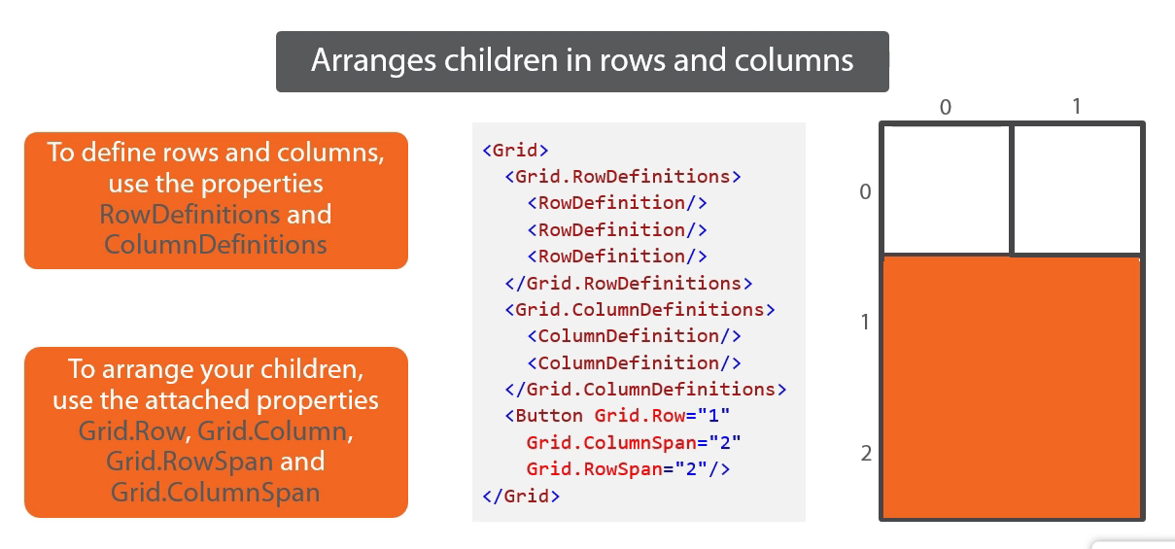

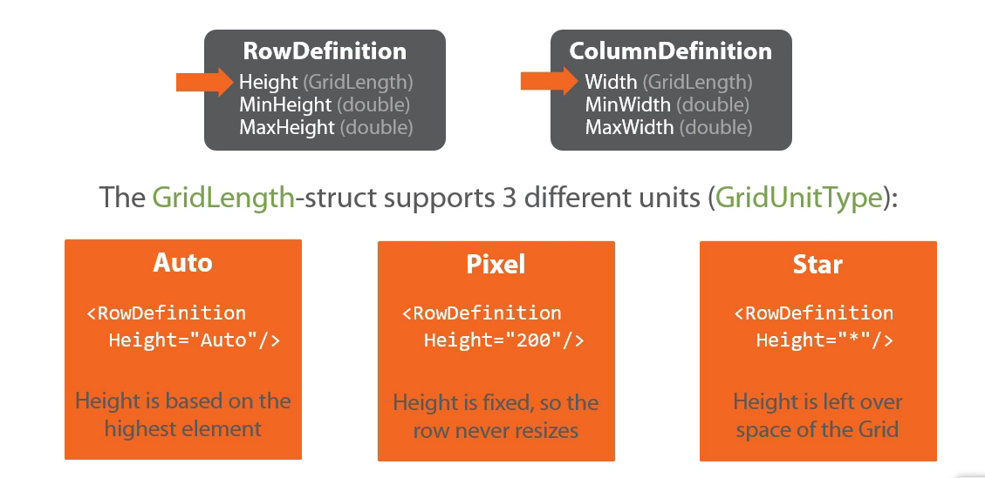

### Demo——FriendViewer

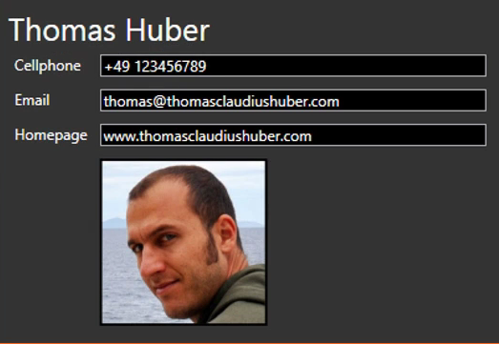

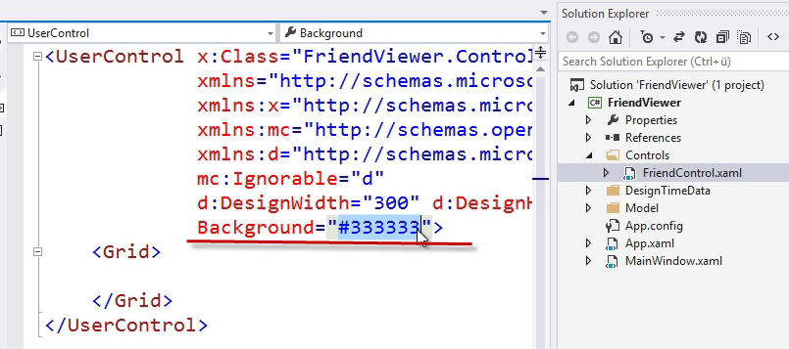

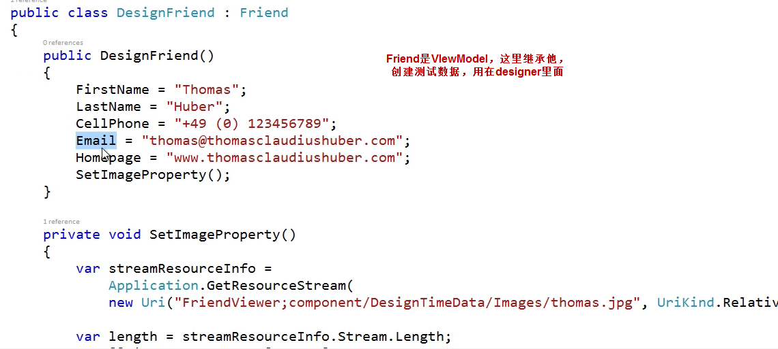

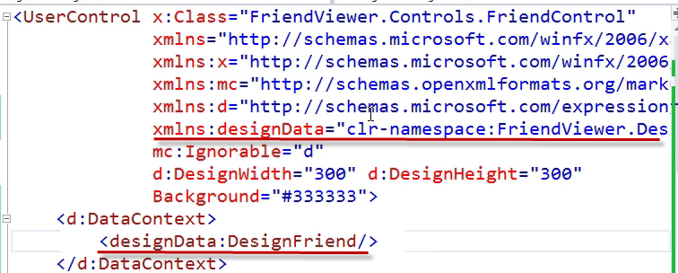

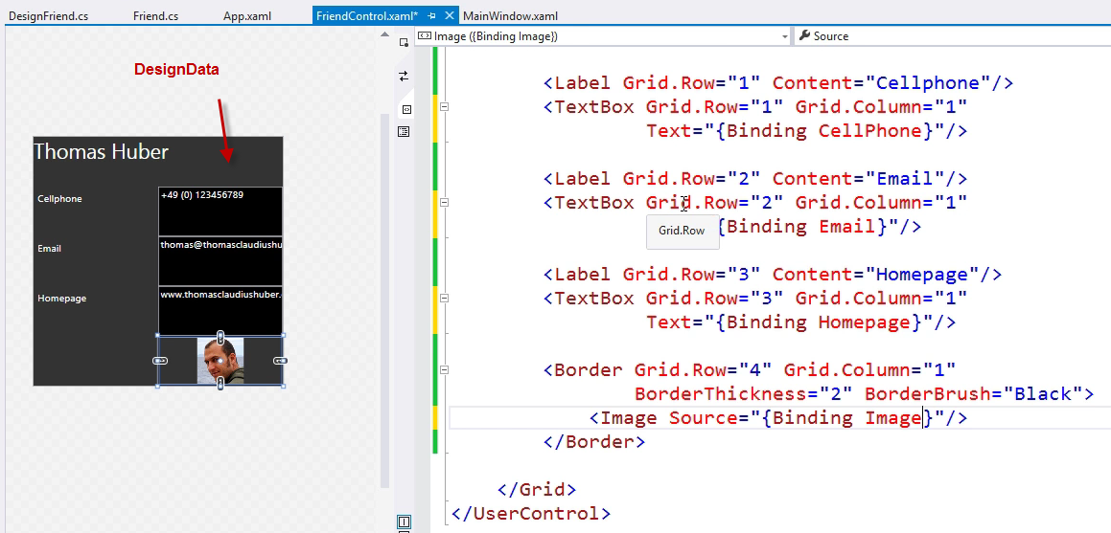

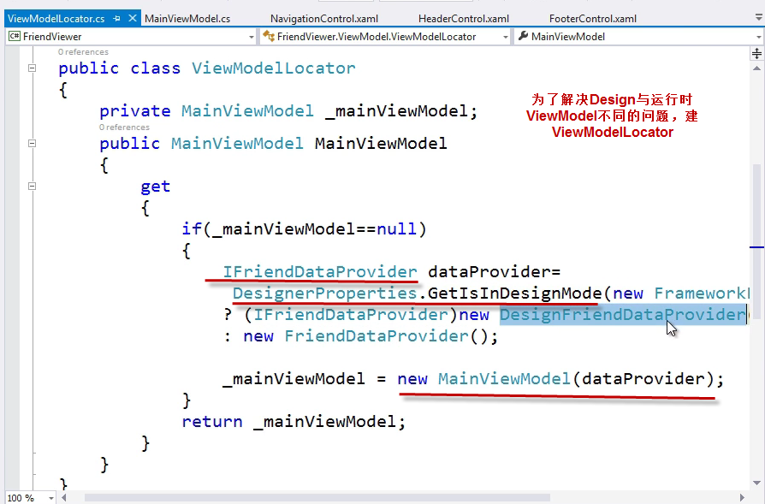

然后做MainWindow，左边是一堆Friends，选中后中间显示Detail

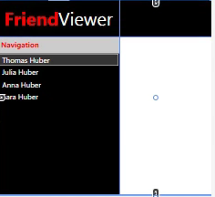

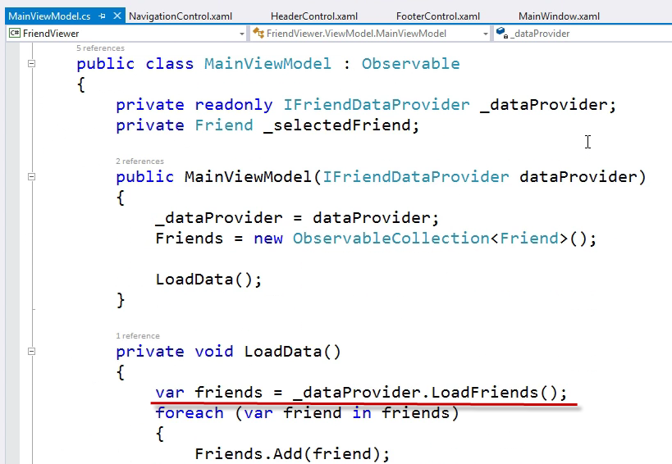

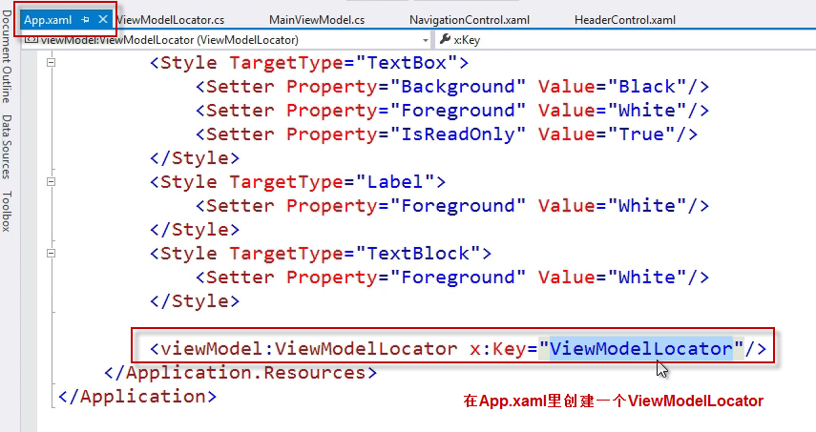

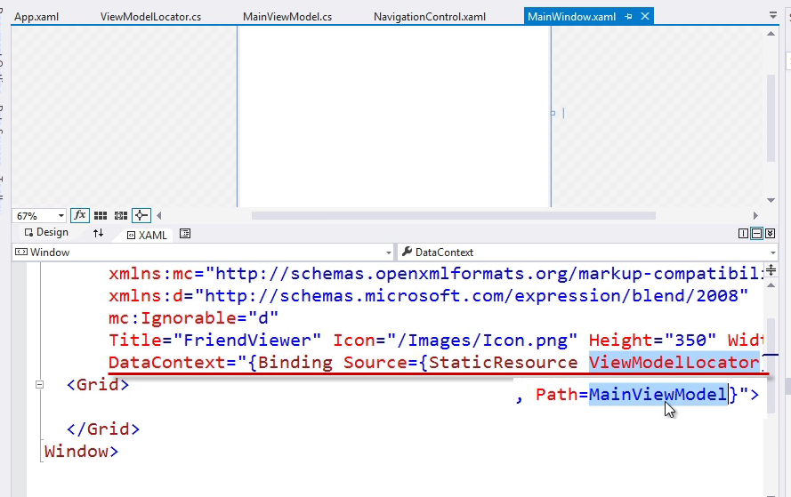

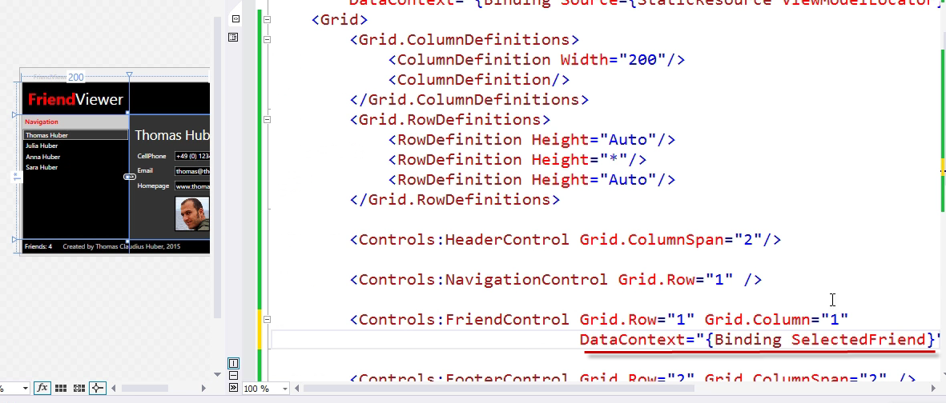

### Grid Splitter

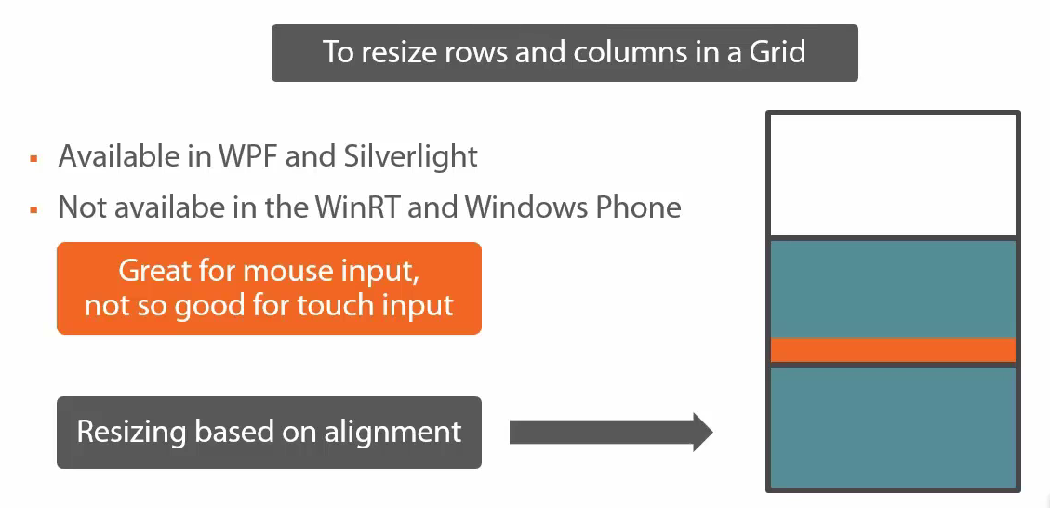

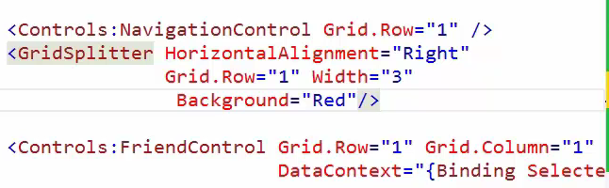

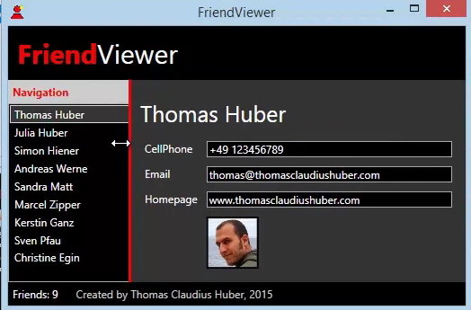

### Canvas

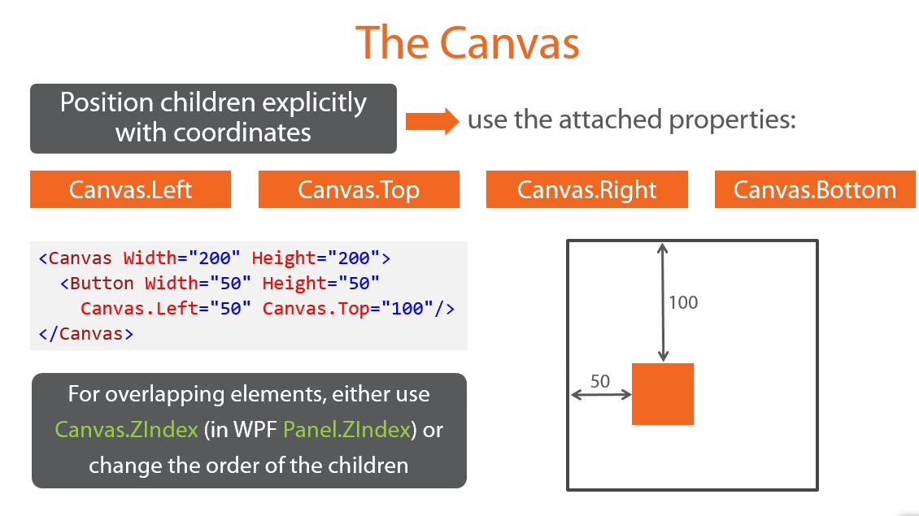

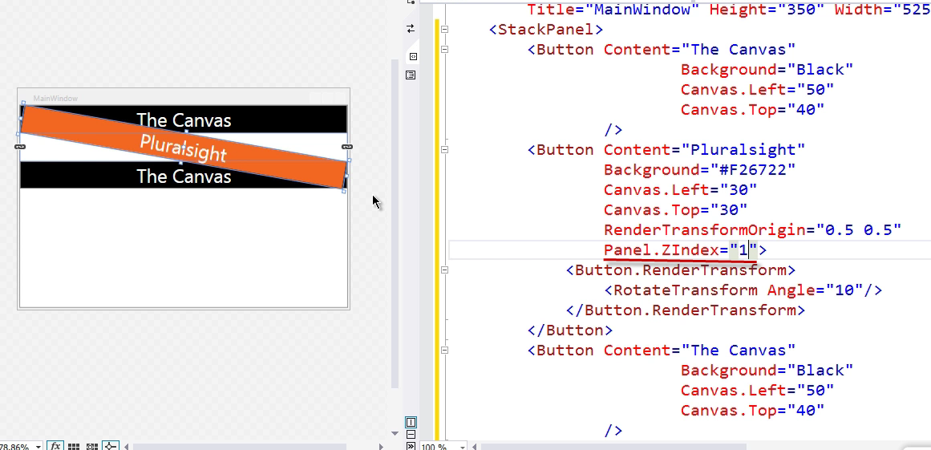

### Stack Panel

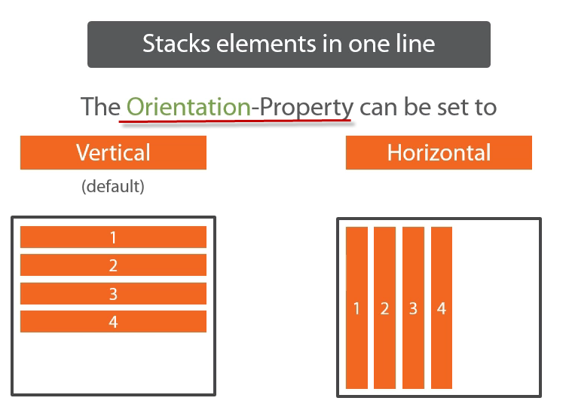

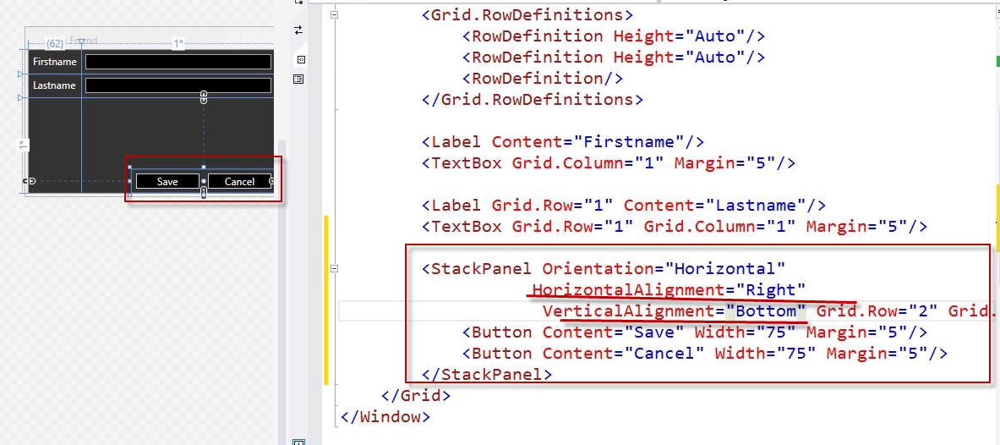

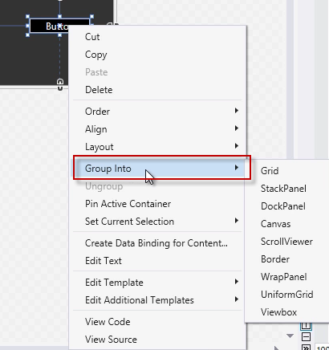

### Wrap Panel

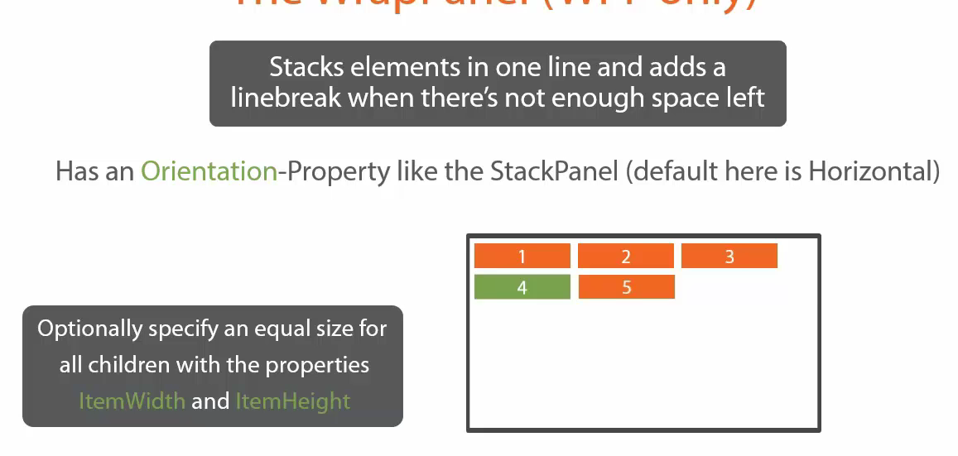

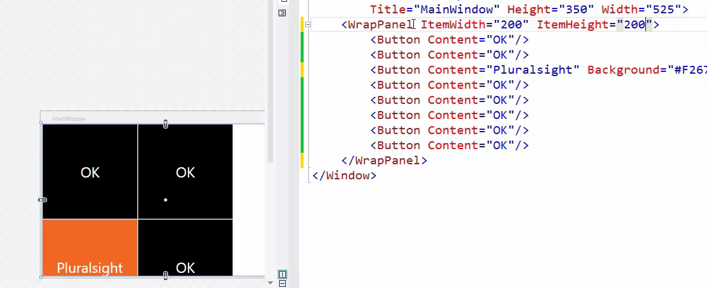

### Dock Panel

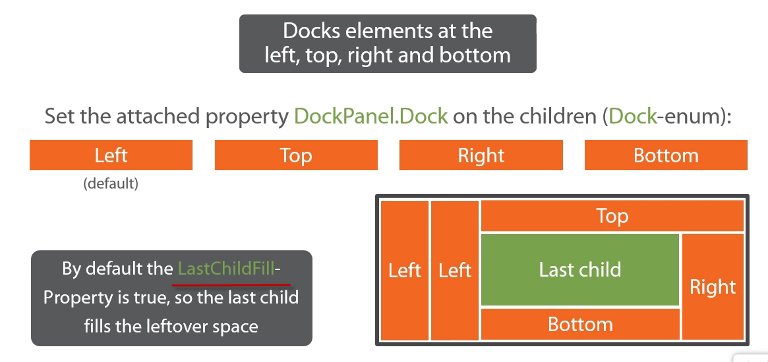

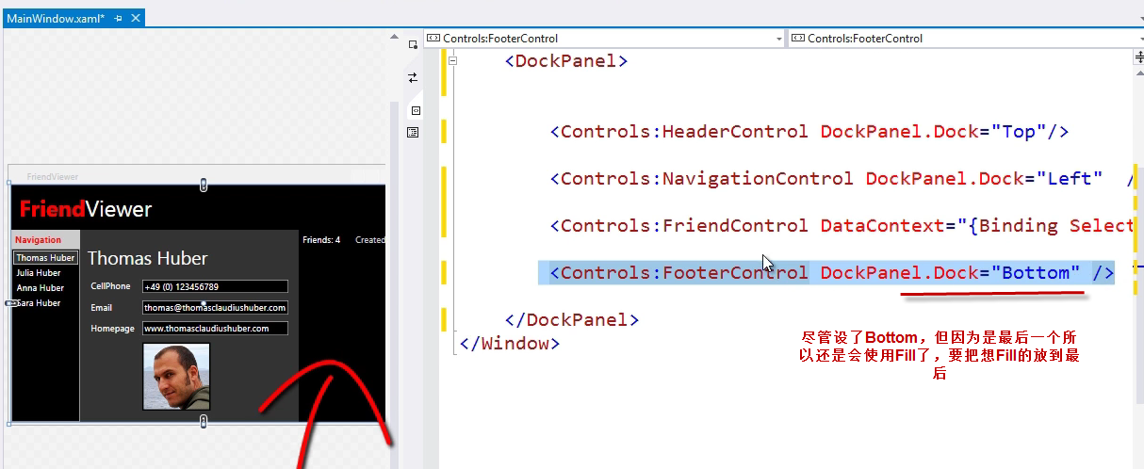

# Transformations & Projections

### Transformations

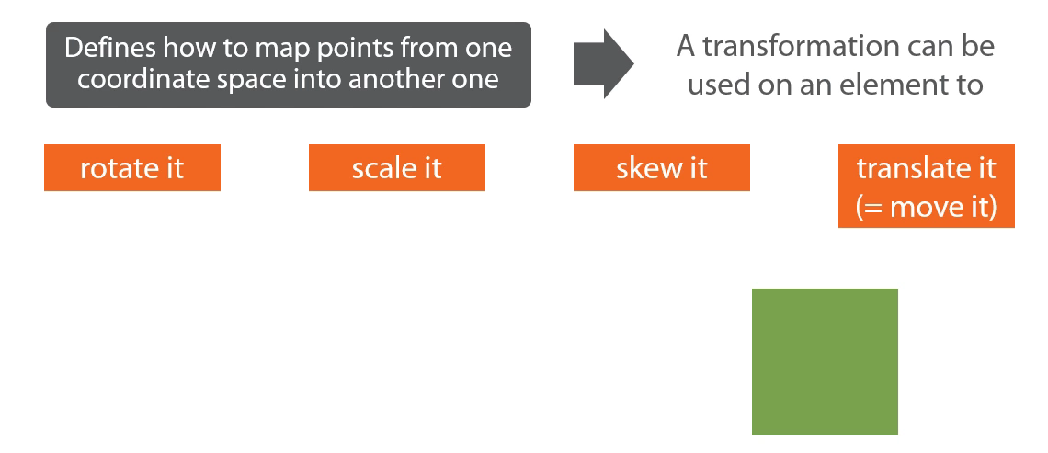

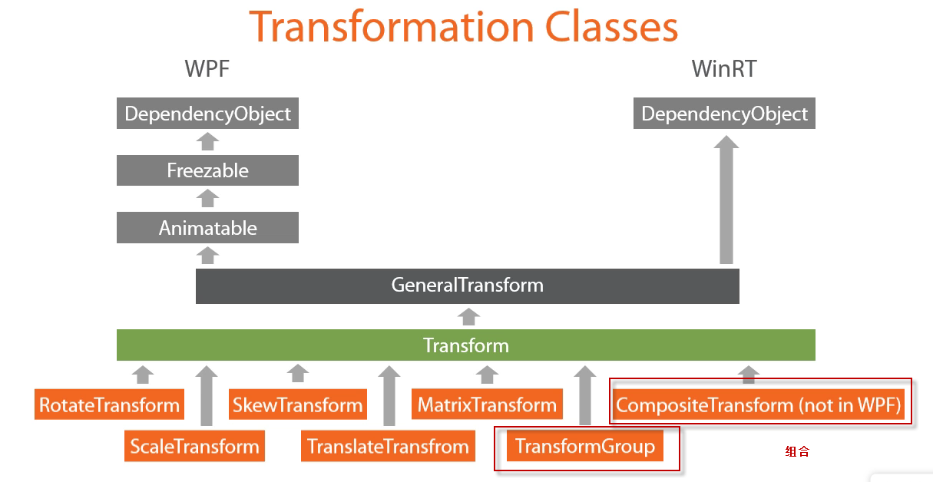

### 控件的Transform Properties

2个属性可以设置Transform对象

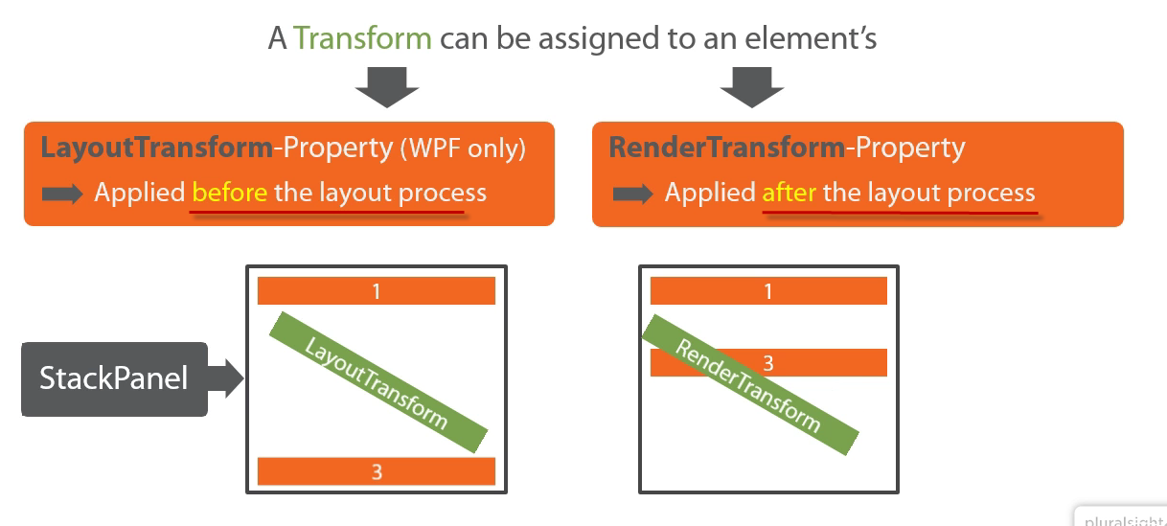

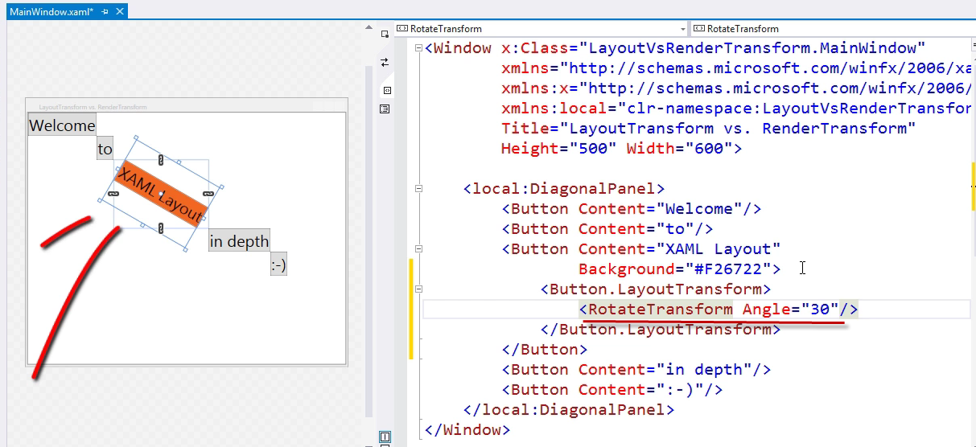

### Origin of RenderTransform

设置旋转的中心点

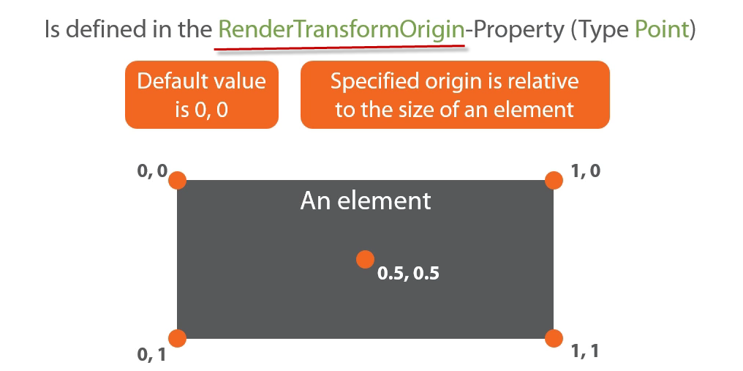

### Demo——Rotate Scale Skew Animcation

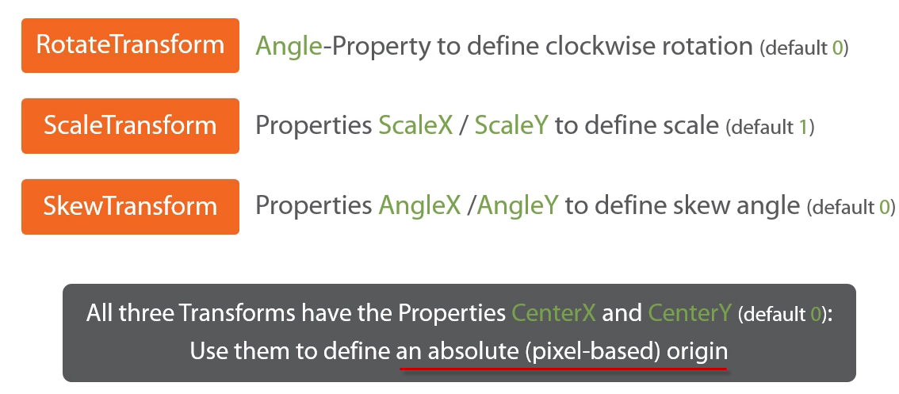

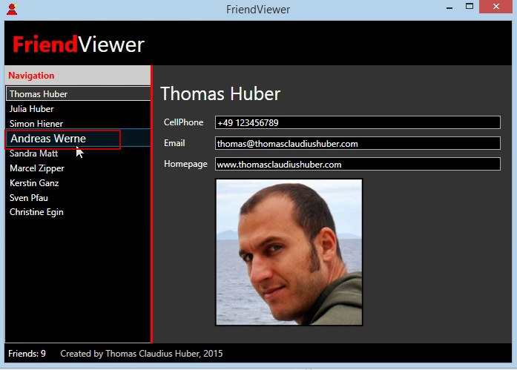

实现这个效果，鼠标移上去会变大

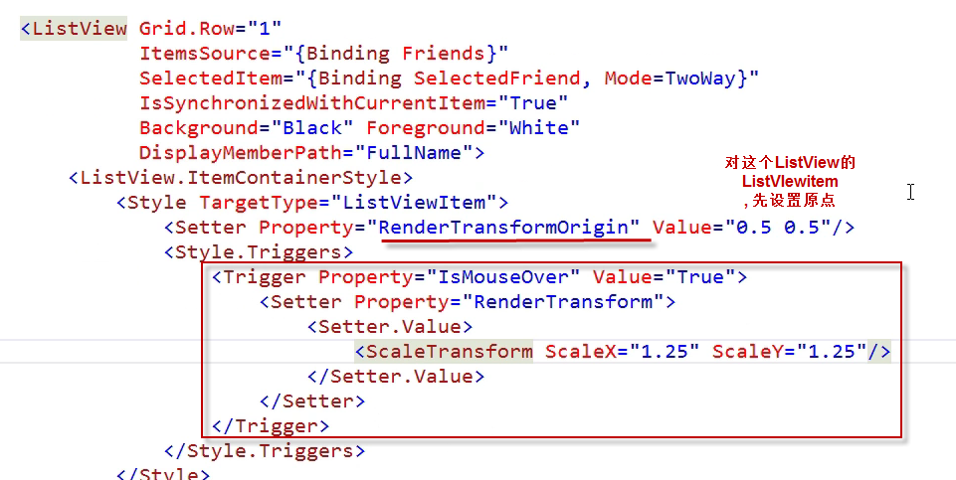

也可以用Animation

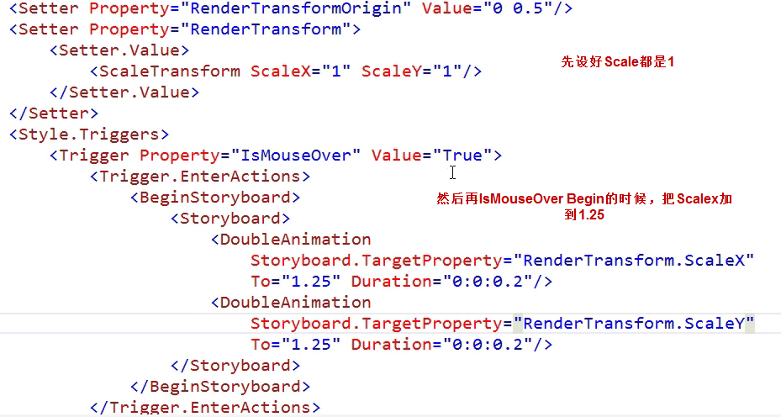

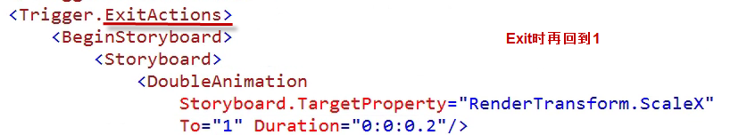

### Demo——Translate

Move an element

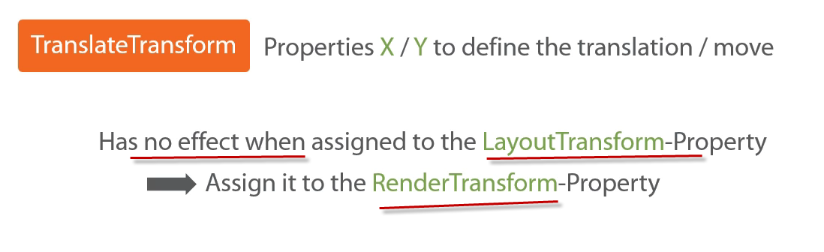

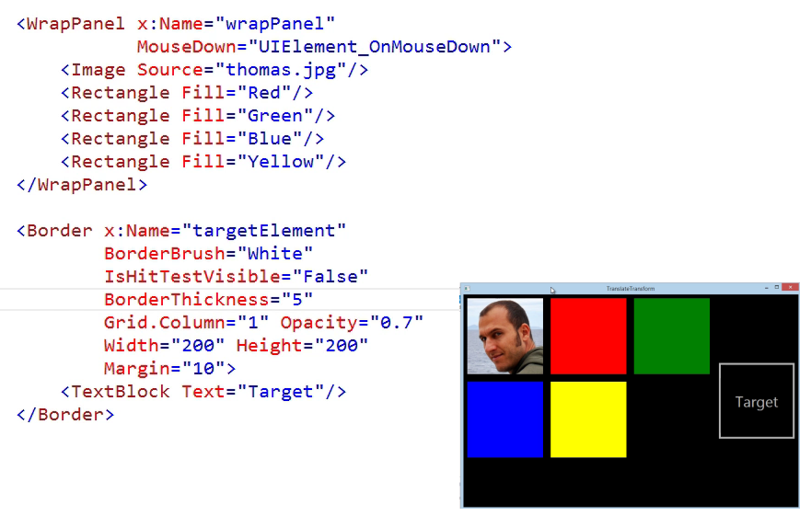

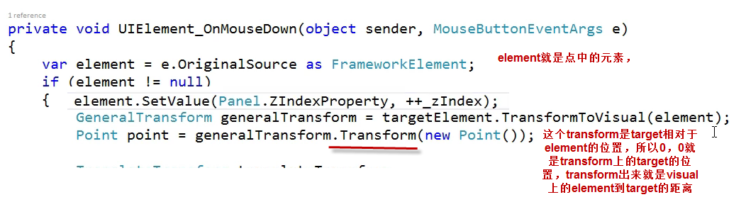

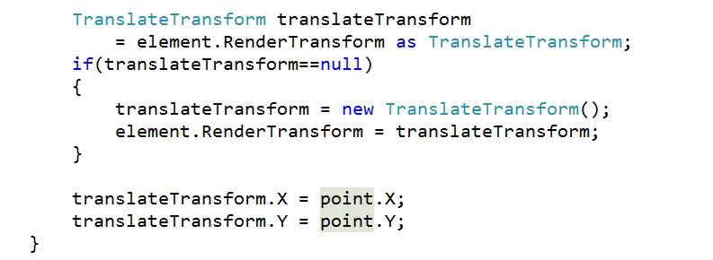

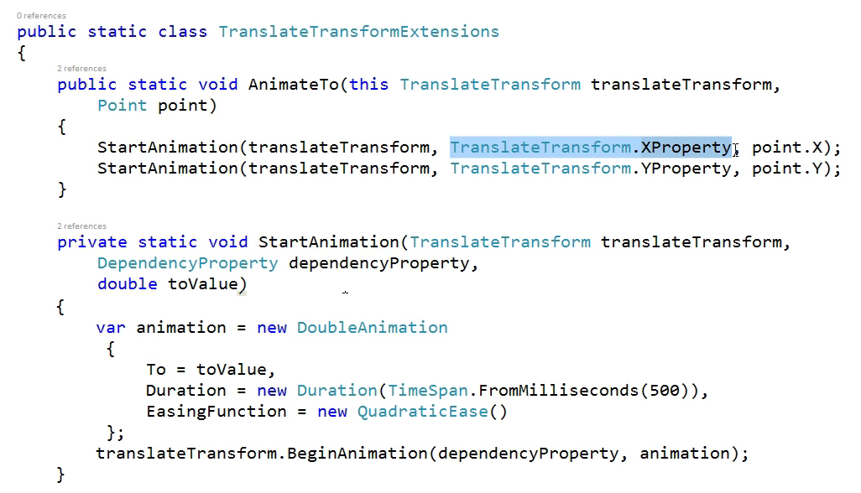

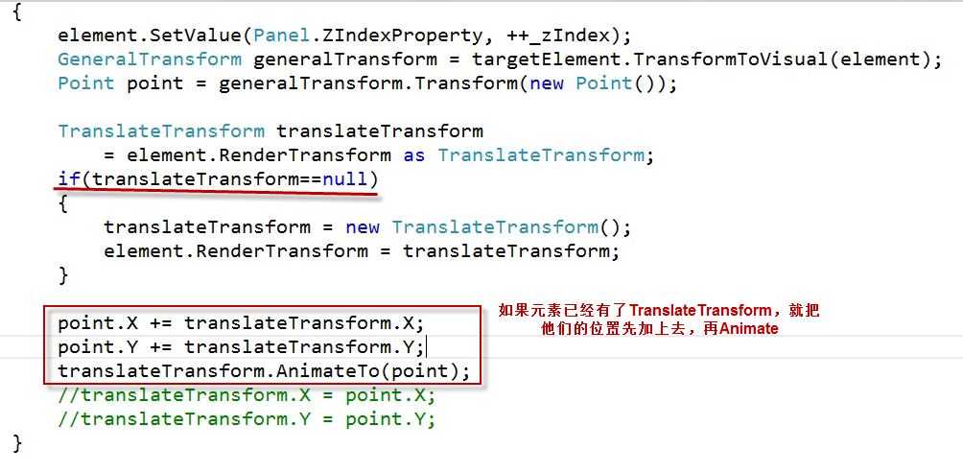

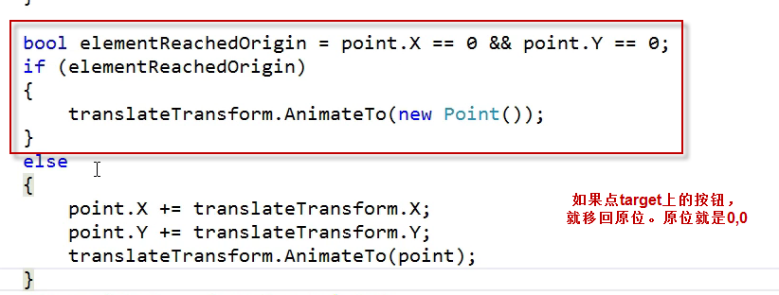

### Demo——FriendViewer Flyout

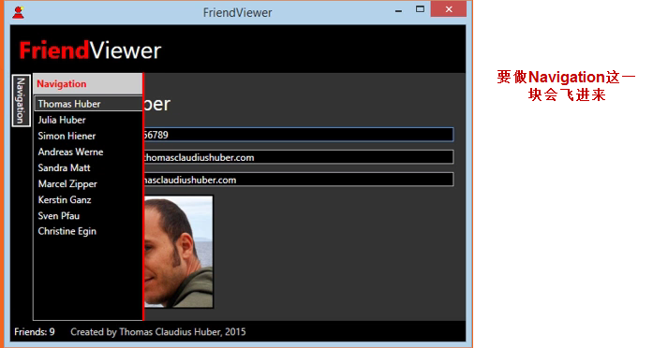

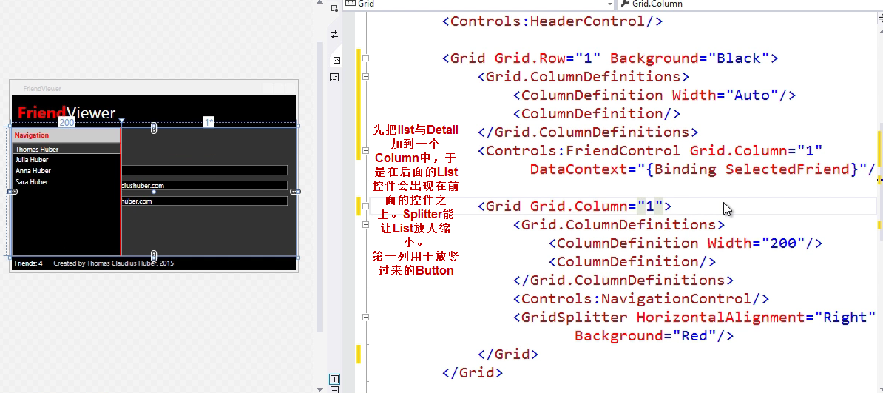

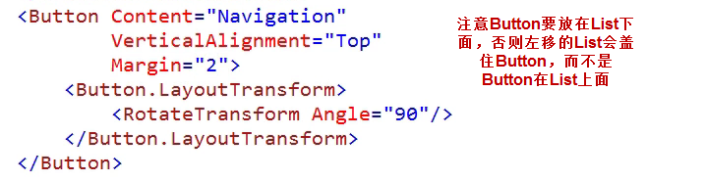

然后要做当鼠标移到Detail上，List要飞出去消失

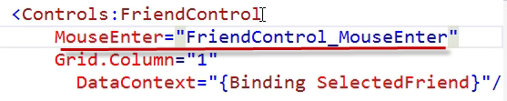

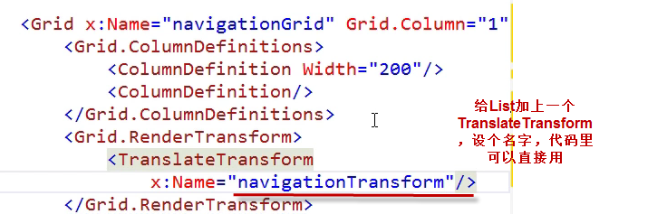

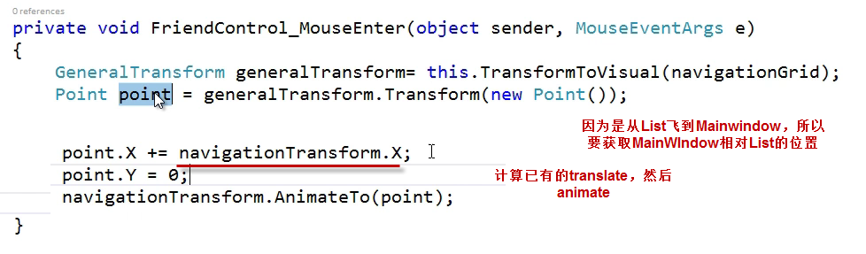

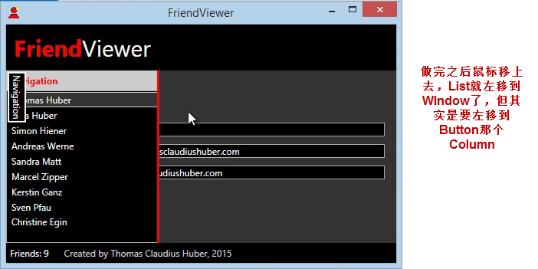



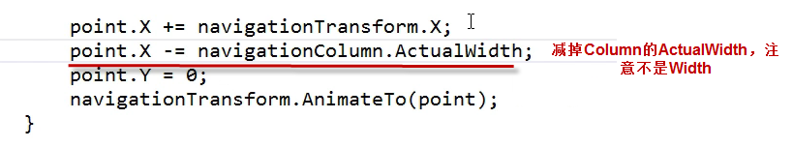

然后做鼠标移到Button上List移出来

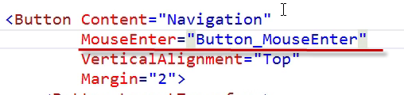

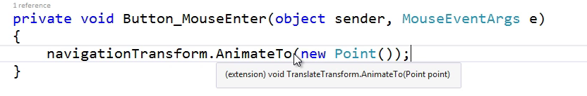

### Combine Transformations

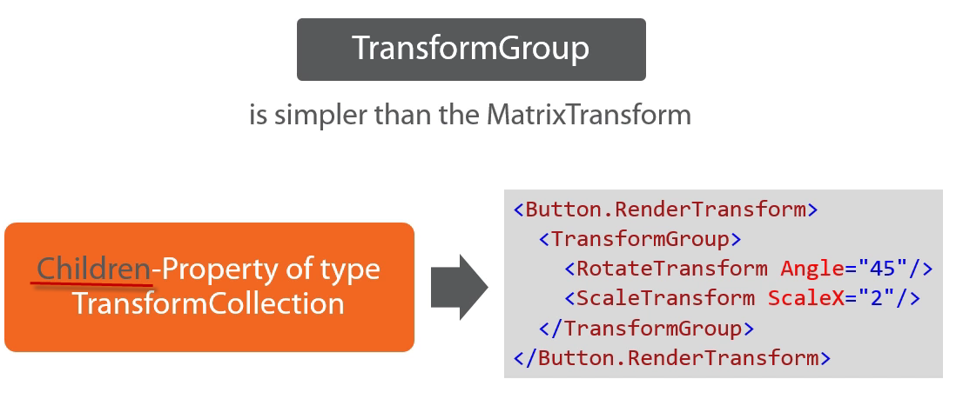

### Projections

**WPF没有！！！**

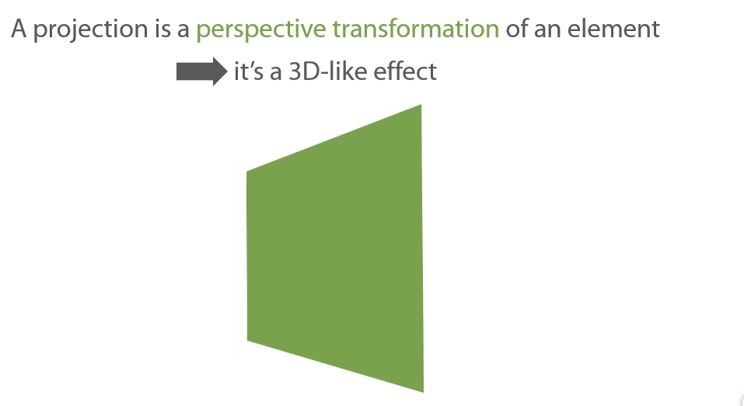

# Advanced Topic

### Grid as Overlay-Container

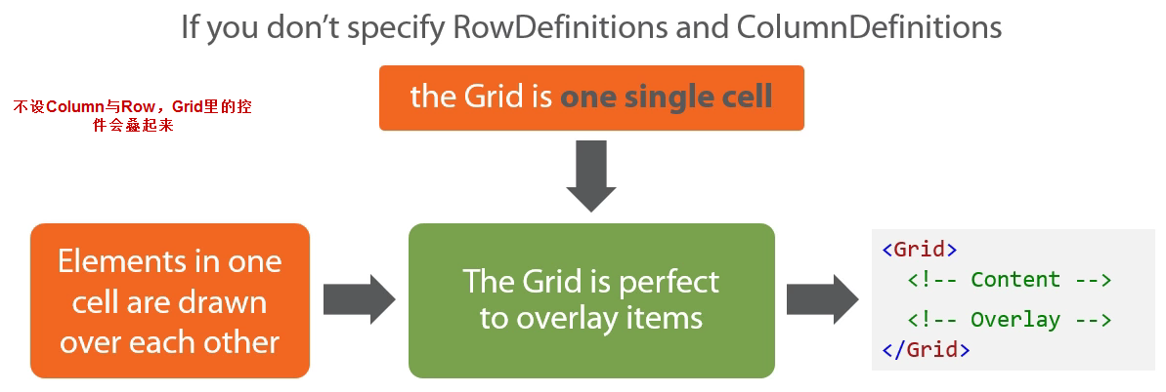

做个loading

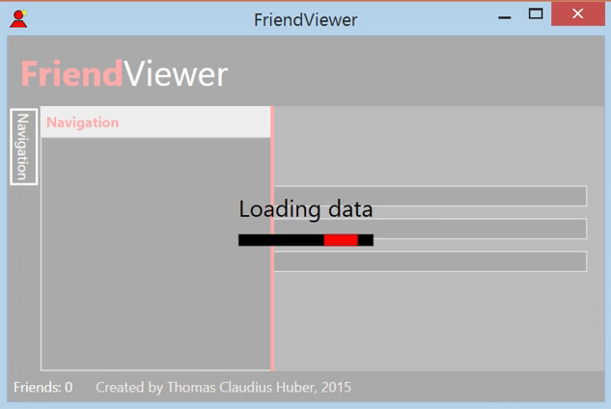

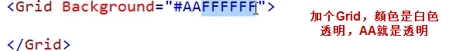

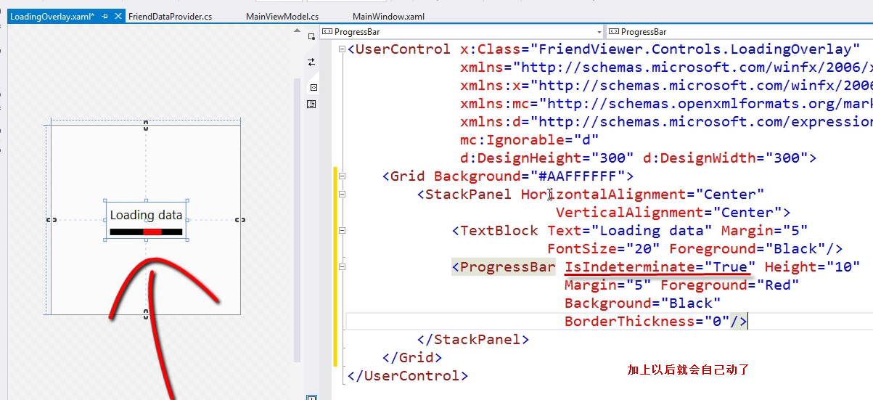

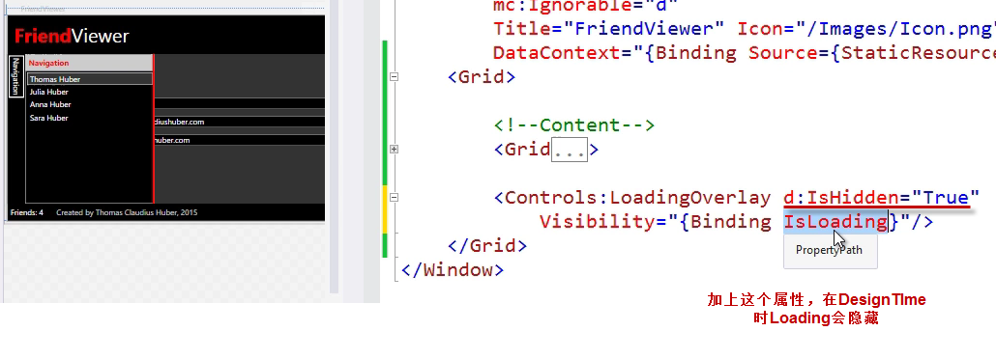

### Grid Shared Size Groups——Pinnable

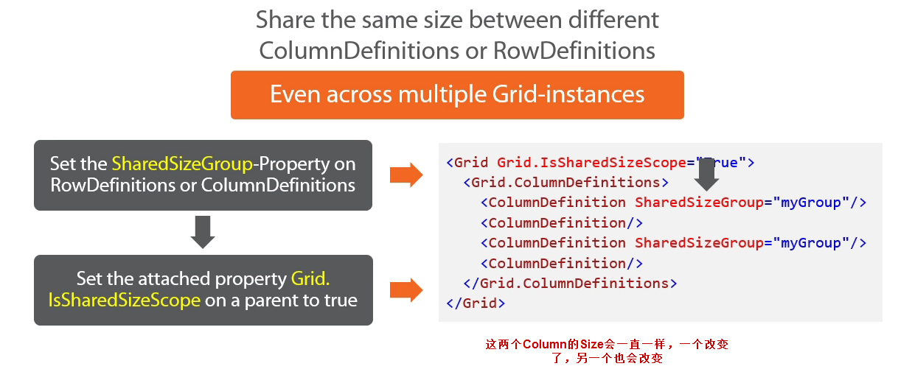

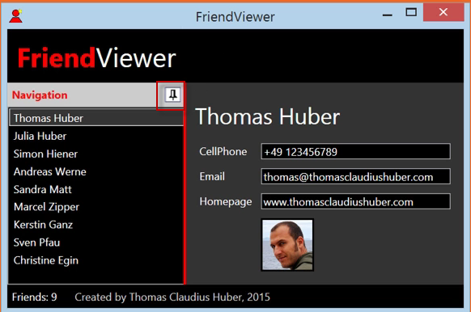

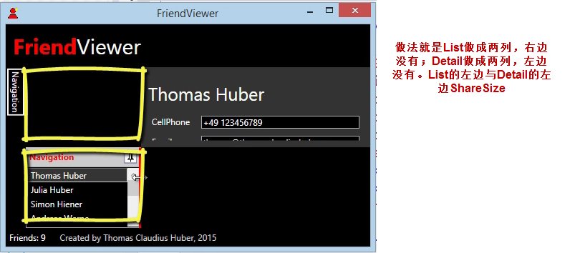

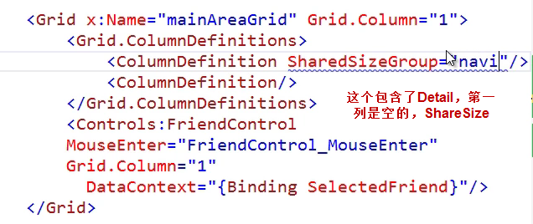

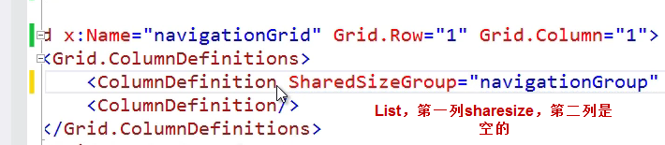



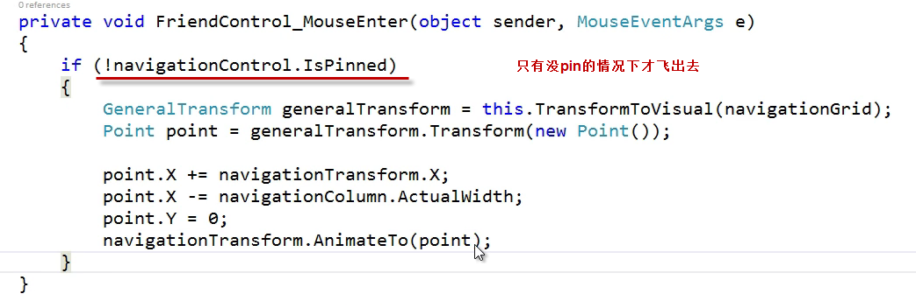

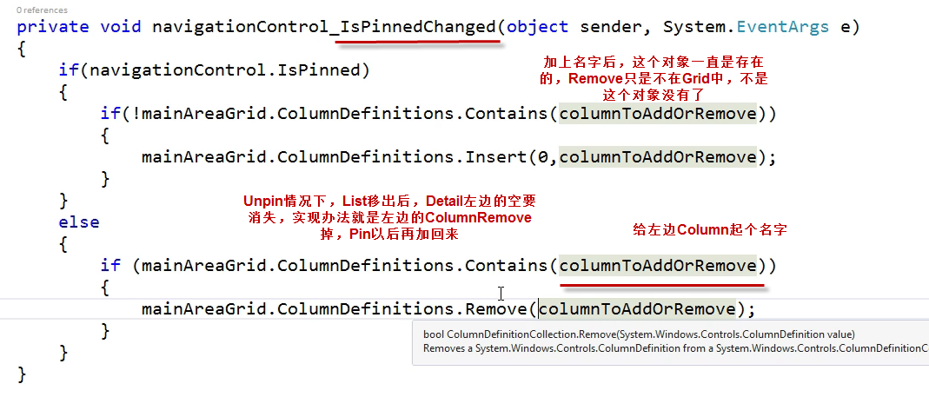

### Layout the Content of a Control

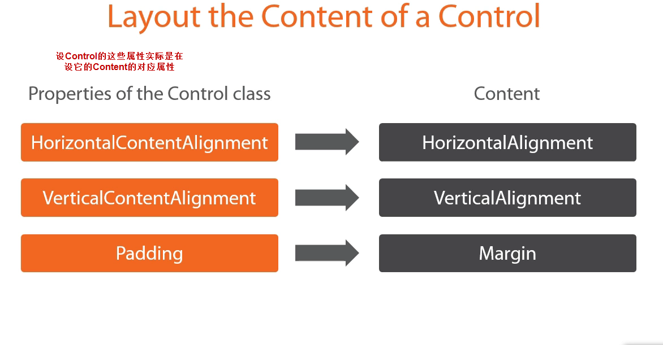

常用的场景是这个

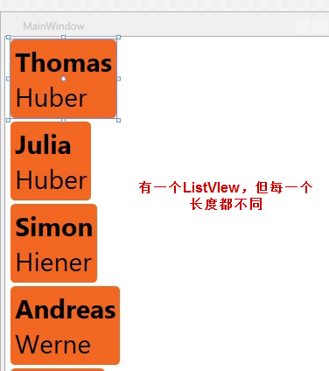

.

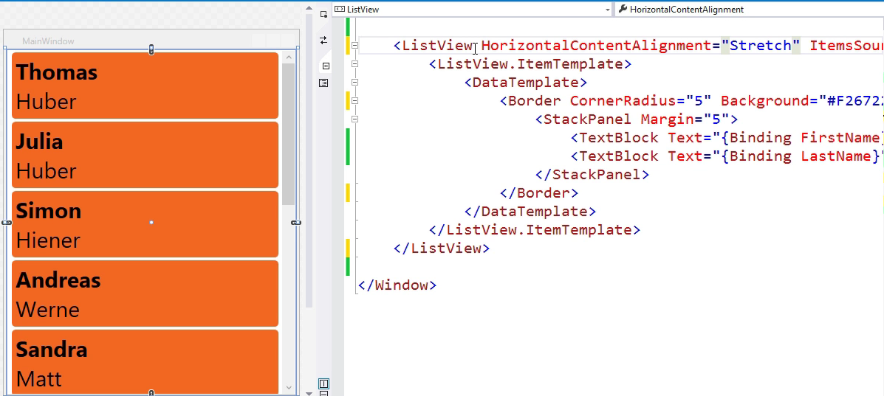

### Change Panel of an ItemsControl

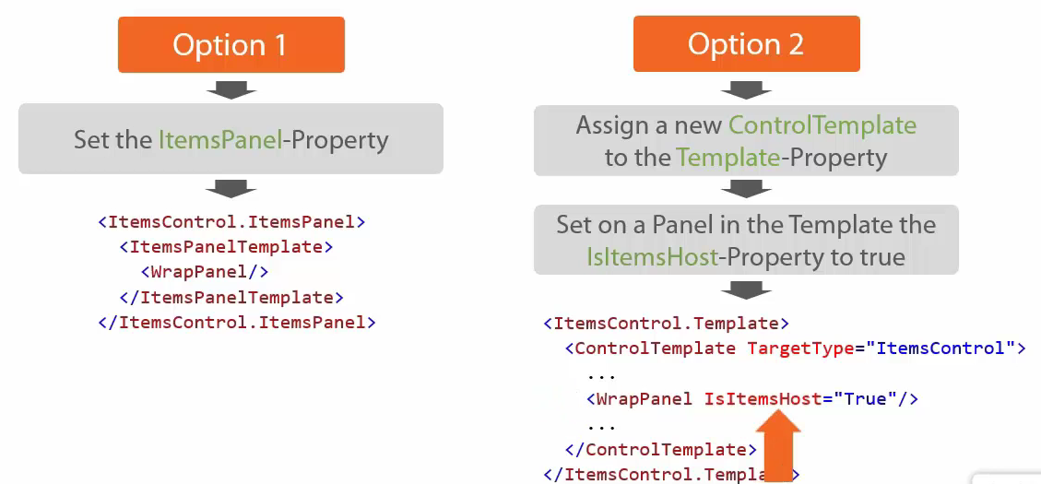

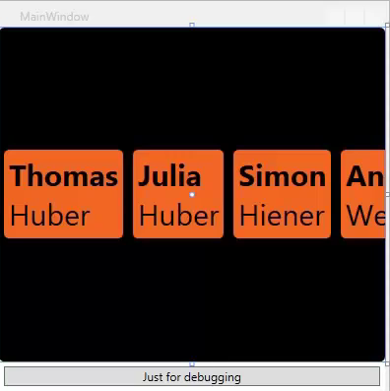

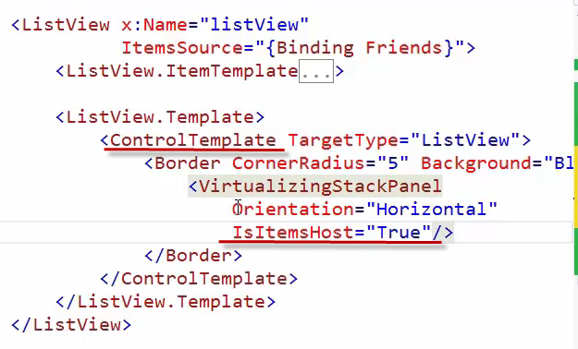

### ScrollViewer

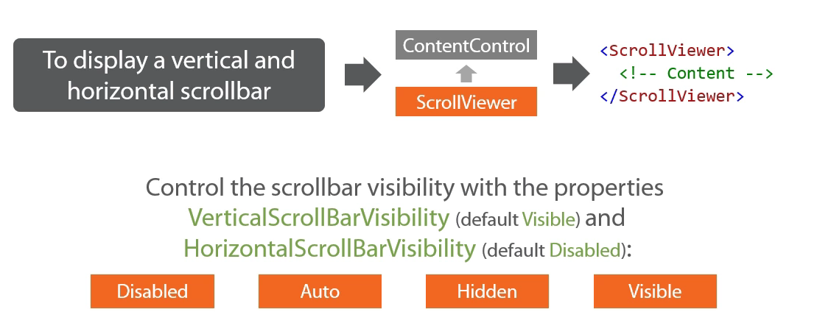

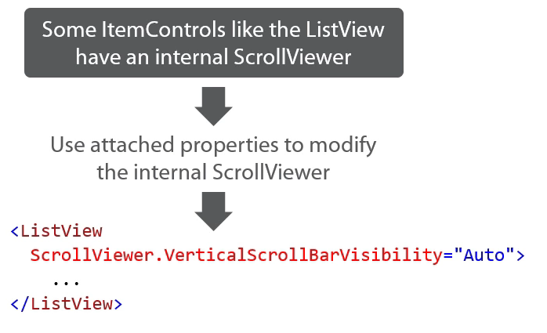

### View Box

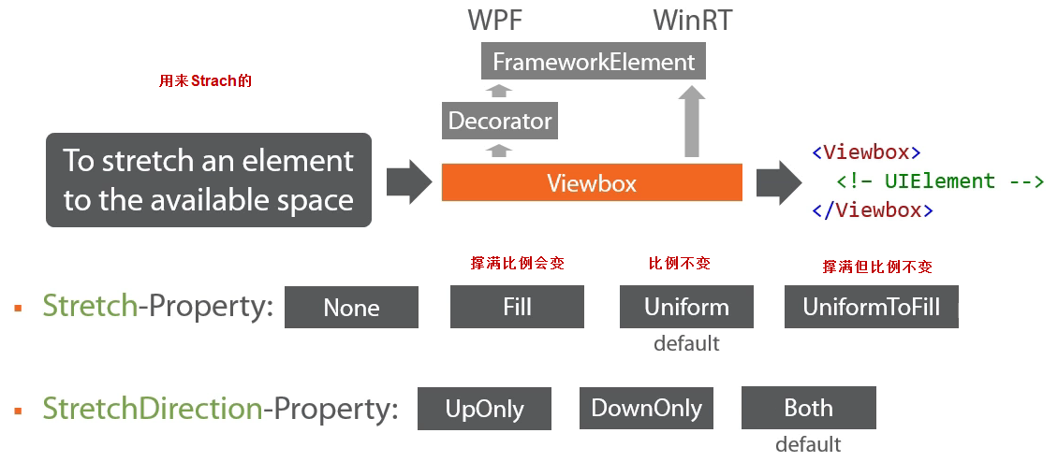

Box里的View会根据大小自动缩小放大

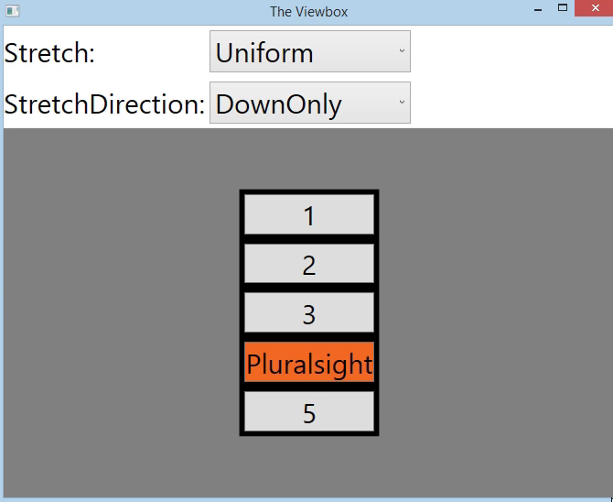

### Animated Move in a Panel

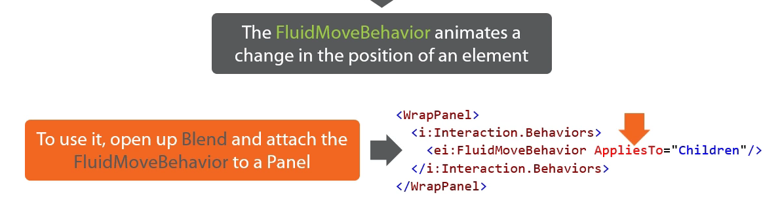

添加时有动画

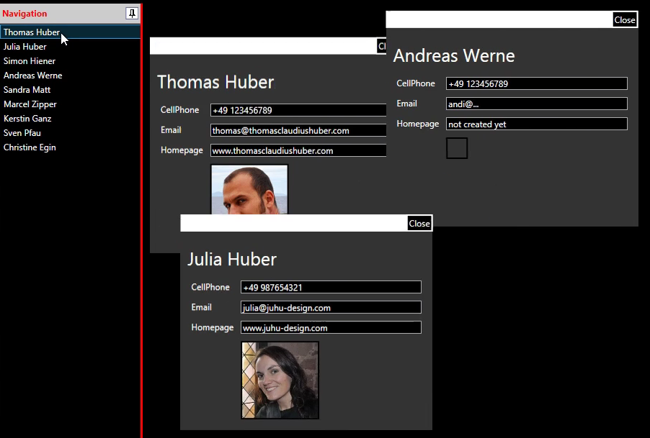

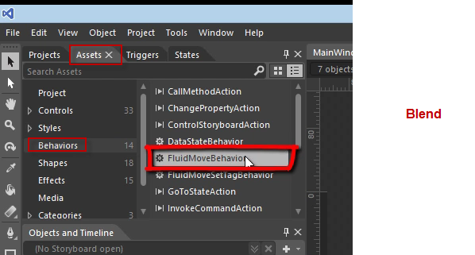

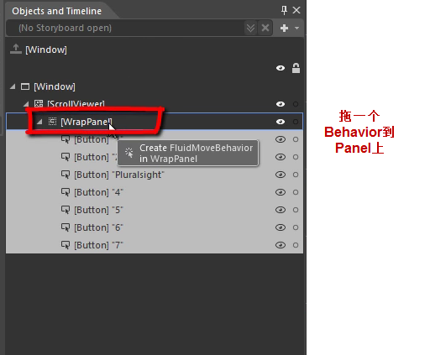

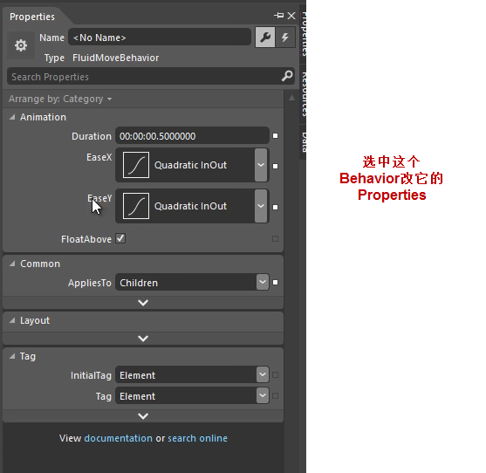

### Demo——New Main Area

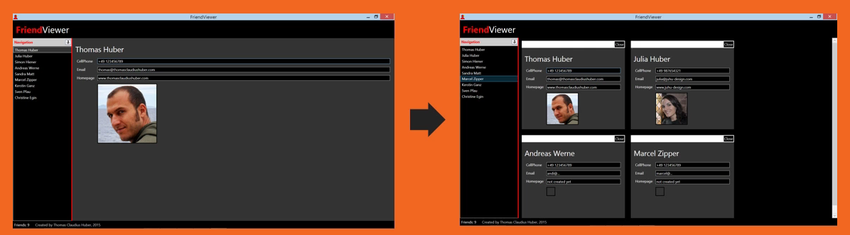

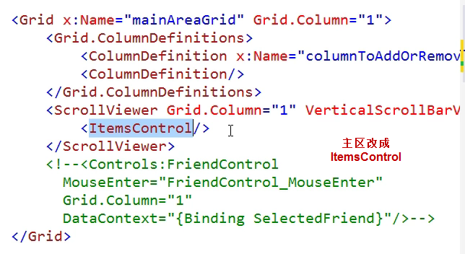

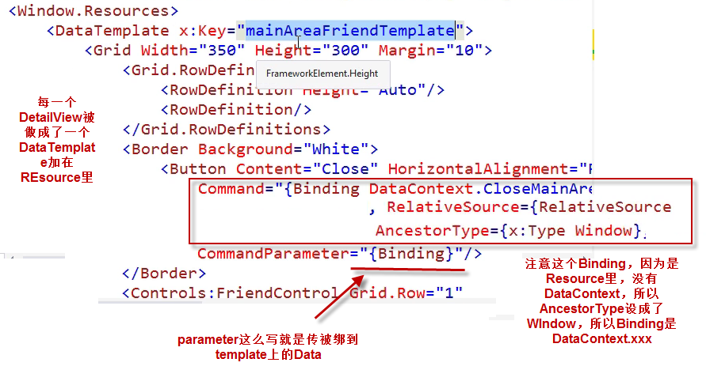

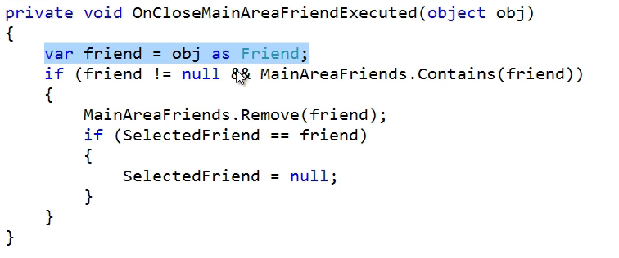

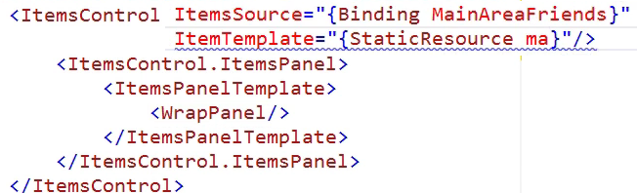

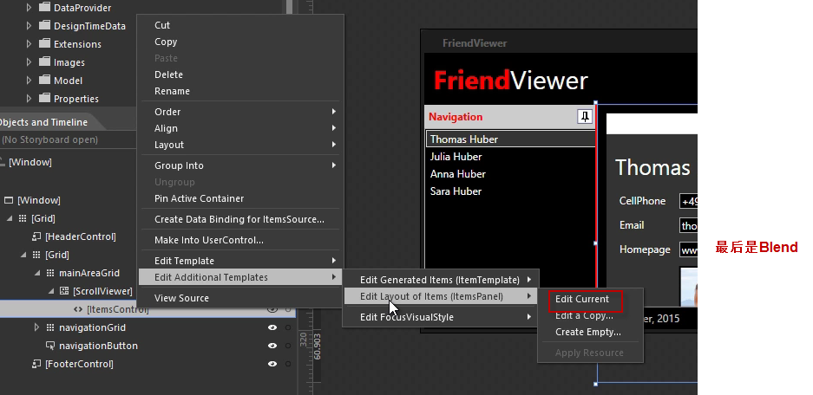

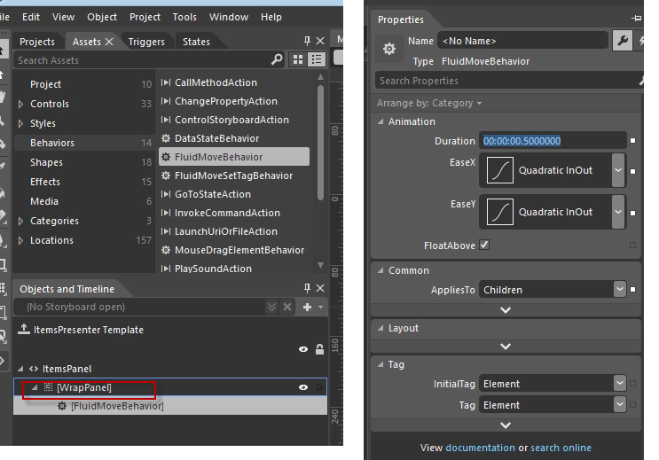

# Styling

### Styles与Properties

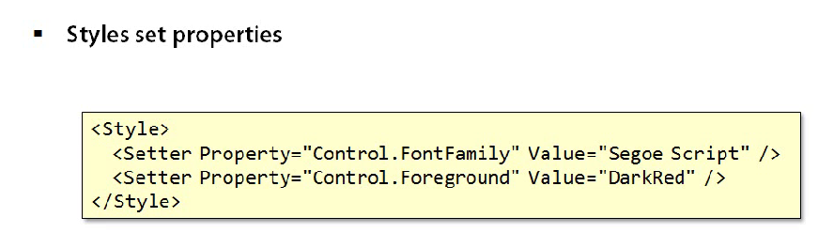

### Resources——使用Style

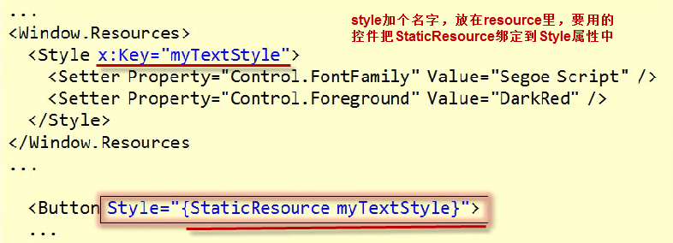

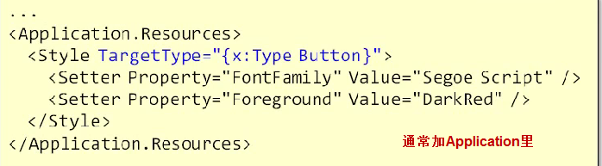

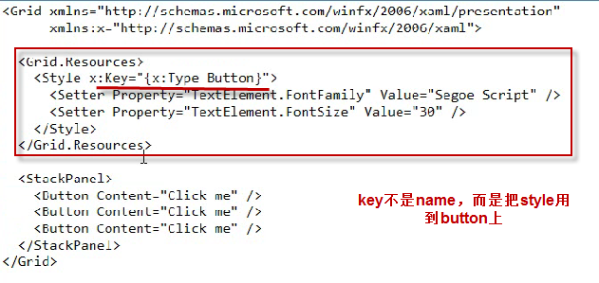

### Extend Style——BasedOn

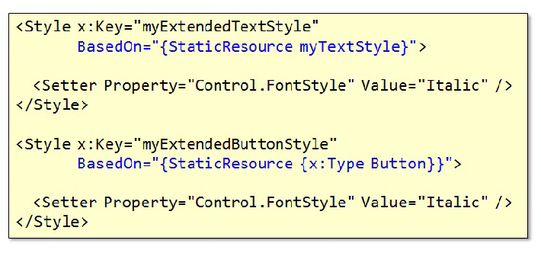

### Mixed Style

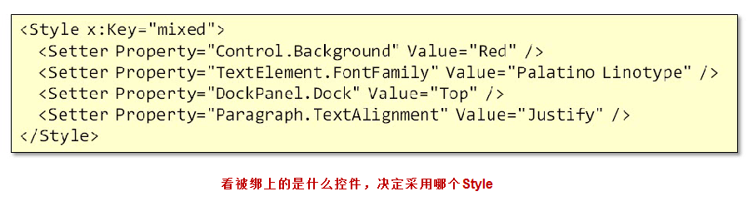

### Style.Trigger

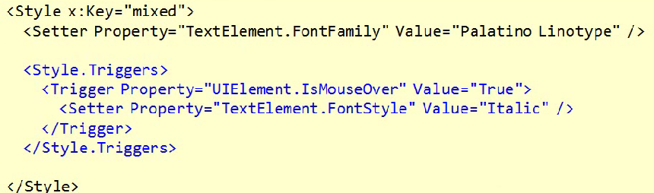

### Animation Trigger

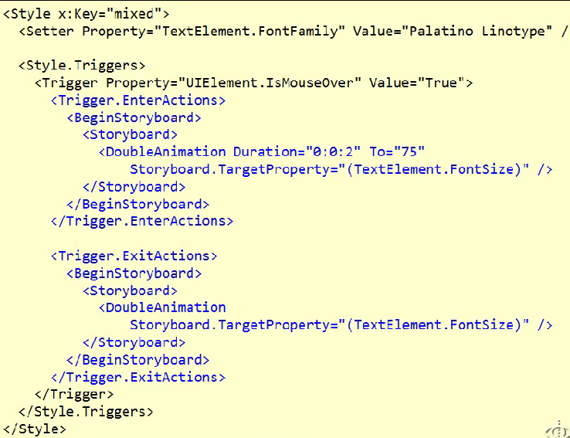

### ItemContainerStyle

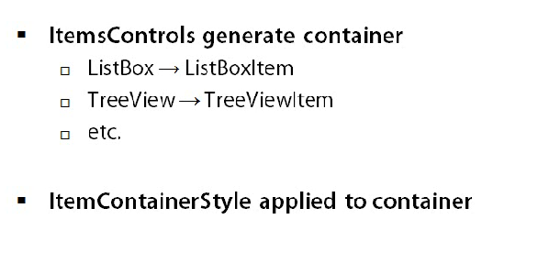

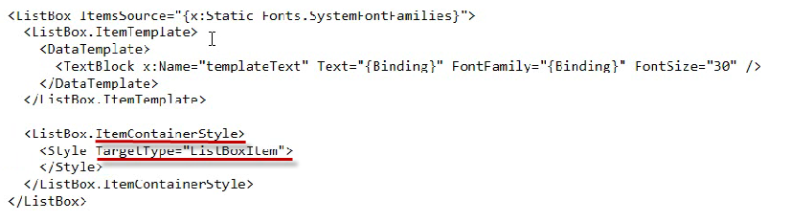

# Behaviors

http://www.pluralsight.com/courses/extending-xaml-applications-behaviors

### Behavior Basics

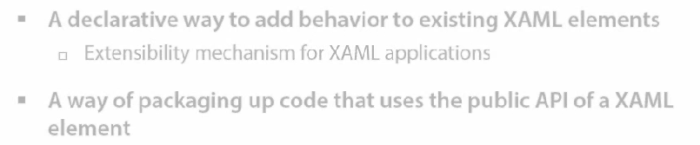

### Dependency Properties

Dependency Object有许多Dependency Property，每个DP都是一个static readonly变量，里面记录了keyValue值，属于每个对象的一般属性用GetSet访问这个静态变量操作属于当前对象的这个属性。DP可以加事件。

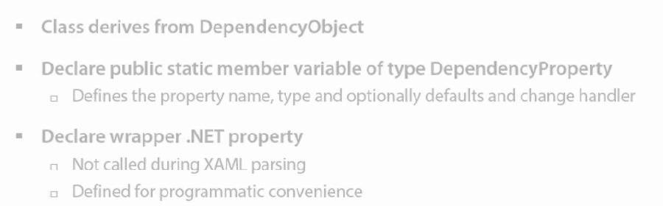

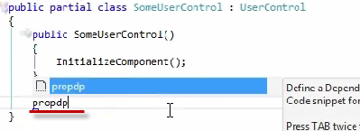

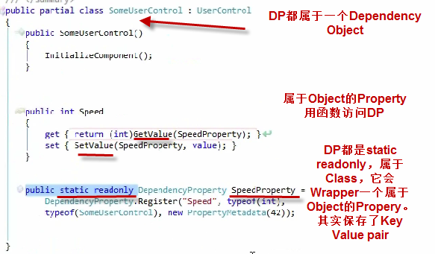

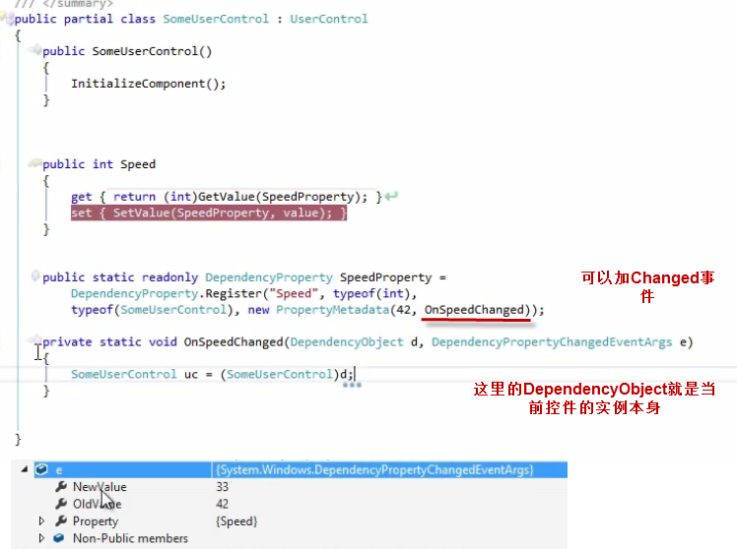

### Attached Properties

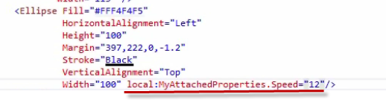

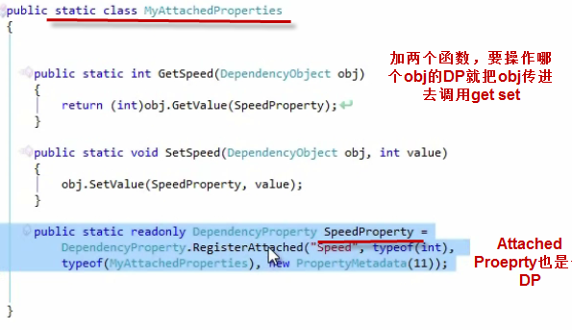.

### Attached Behaviors with Attached Property

当一个属性变化时能引起处理就是Behavior

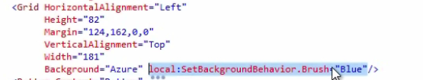

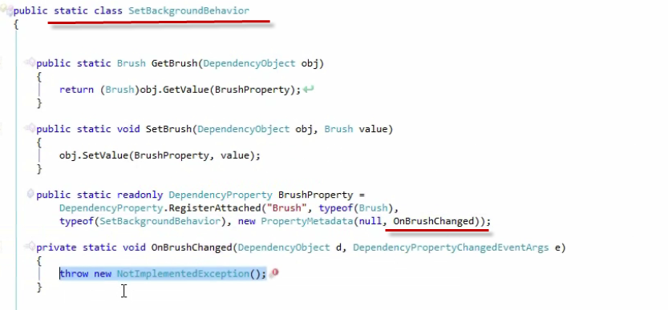

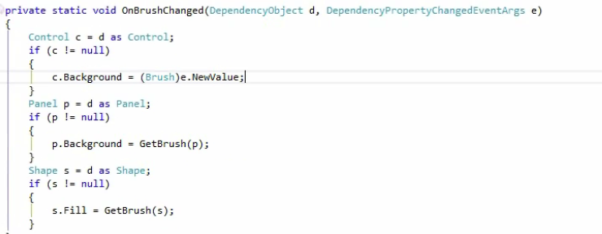

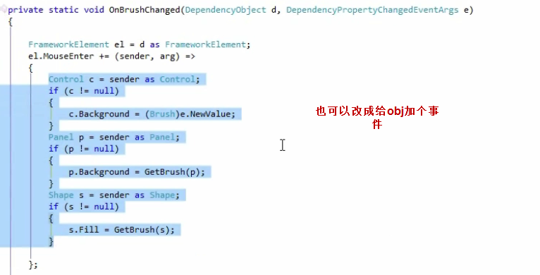

### Behaviors in Blend

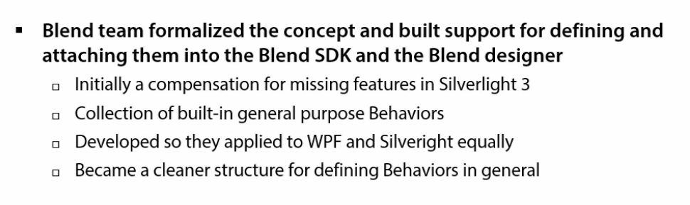

# Blend Behaviors

### Behaviors Actions Triggers

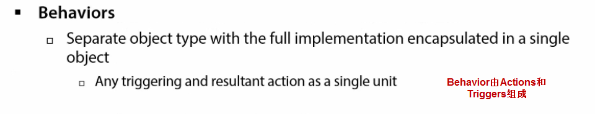

### Demo——Blend Behaviors

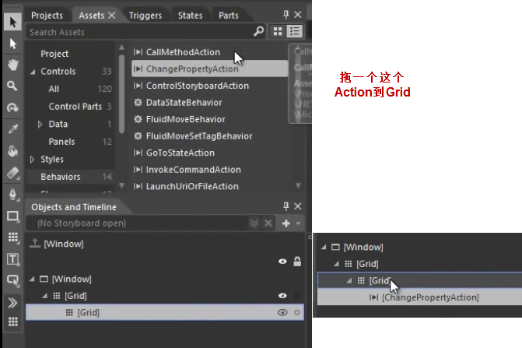

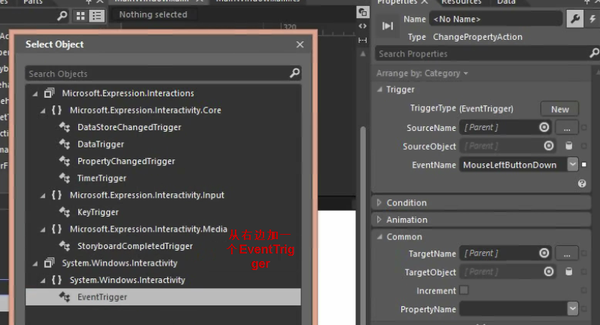

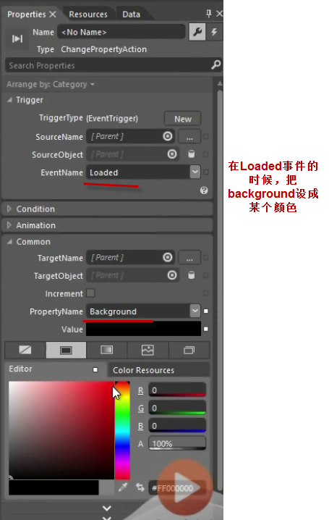

# Animate with Behaviors

### FluidMoveBehavior

FluidMoveBehavior用于WrapPanel

### MouseDragElementBehavior RemoveElelemtAction

MouseDragElementBehavior拖到Item上以后就可以用鼠标拖动这个对象了

### TranslateZoomRotateBehavior

# MVVM In Depth

<http://www.pluralsight.com/courses/wpf-mvvm-in-depth>

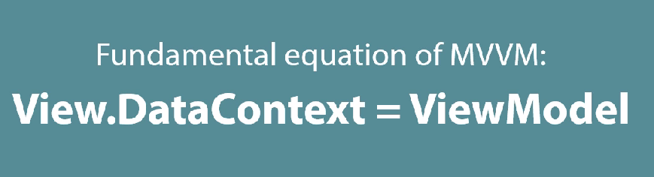

### 谁创建谁

有两种方式

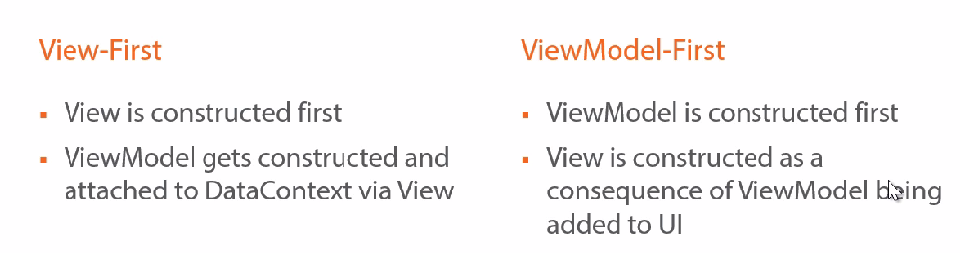

### Async in VM

后台拿数据的Repository返回的就是Task

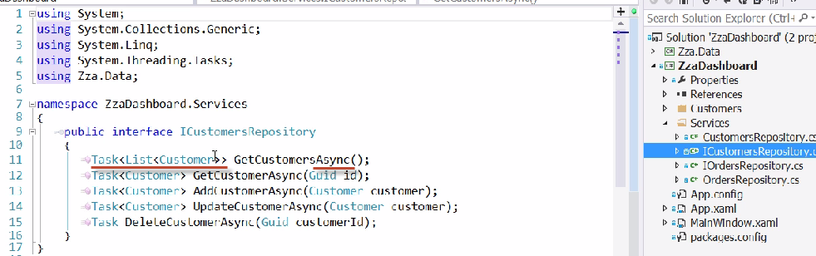

实现方法就是用Async

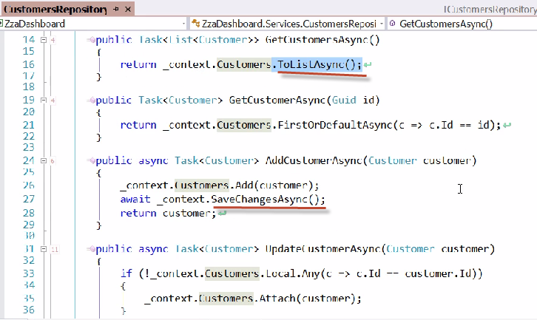

创建View的时候，建一个DevenpendyProperty，然后在View的OnLoad时使用，加上await就可以了，最后设置DataContext

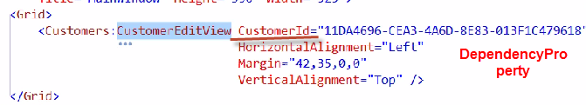

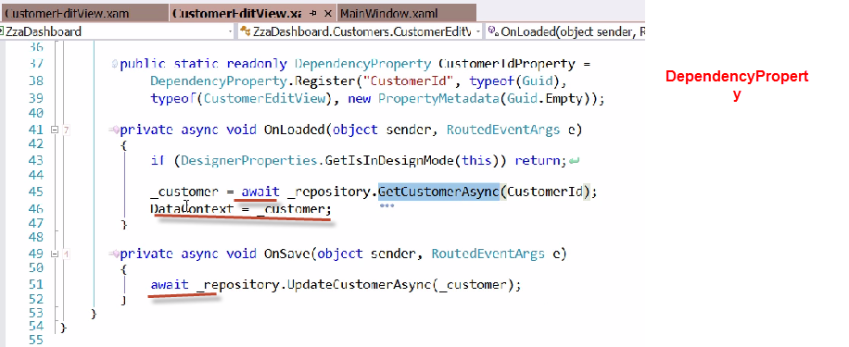

如果要用ＶＭ，就不用上面的做法了

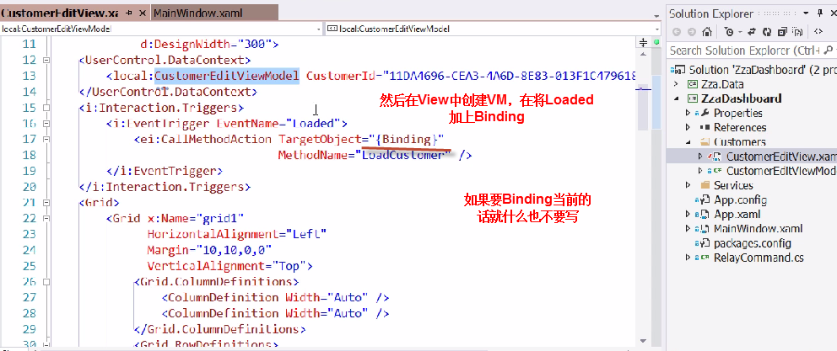

在VIewModel中函数加上async

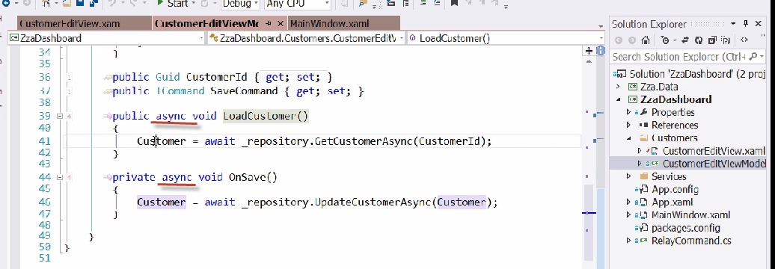

### Hook up Views and ViewModels——View First

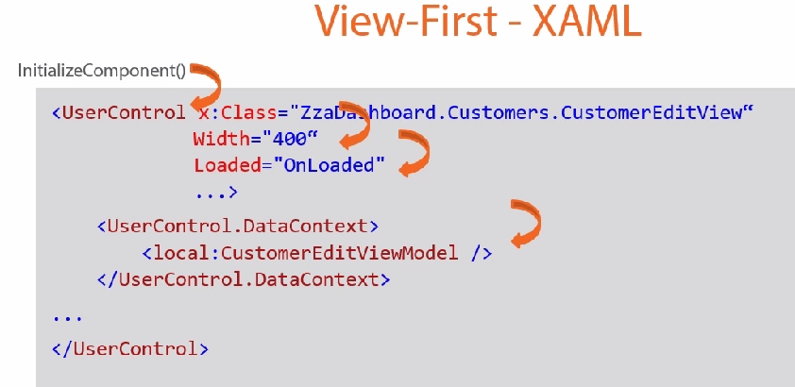

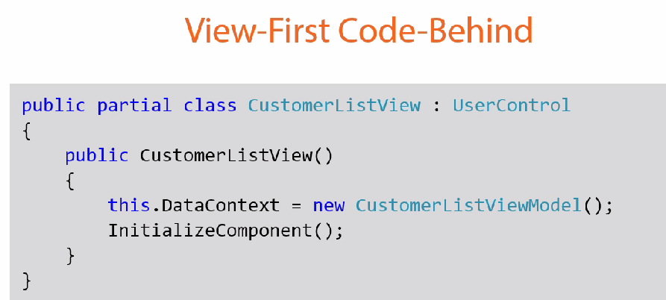

### VM在Design Time的初始化

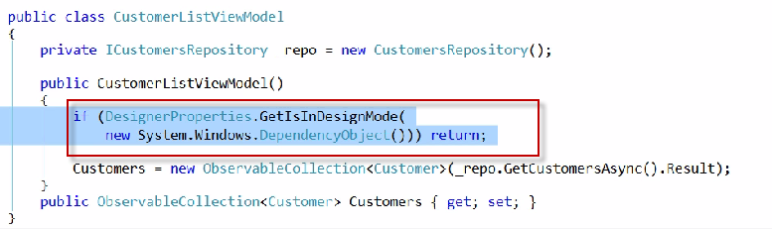

### View First——VM Locator

就是根据Convention看这个View应该是什么VM

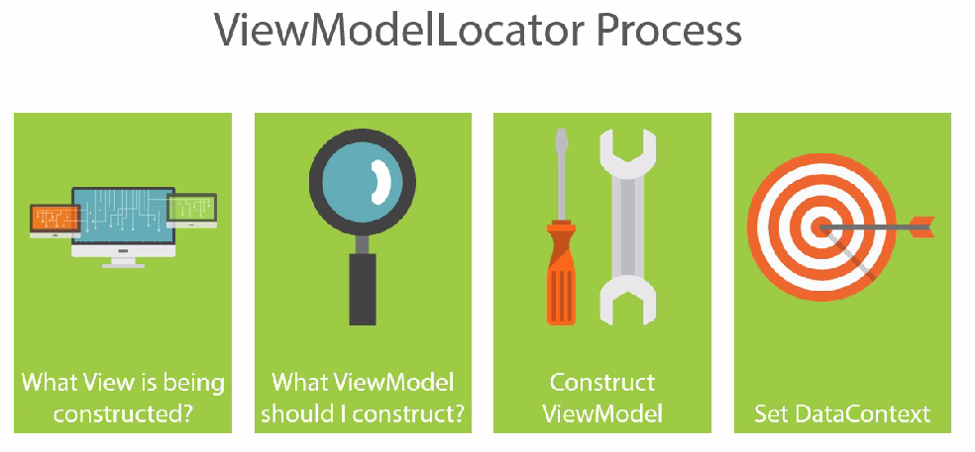

手动创建一个ViewModelLocator

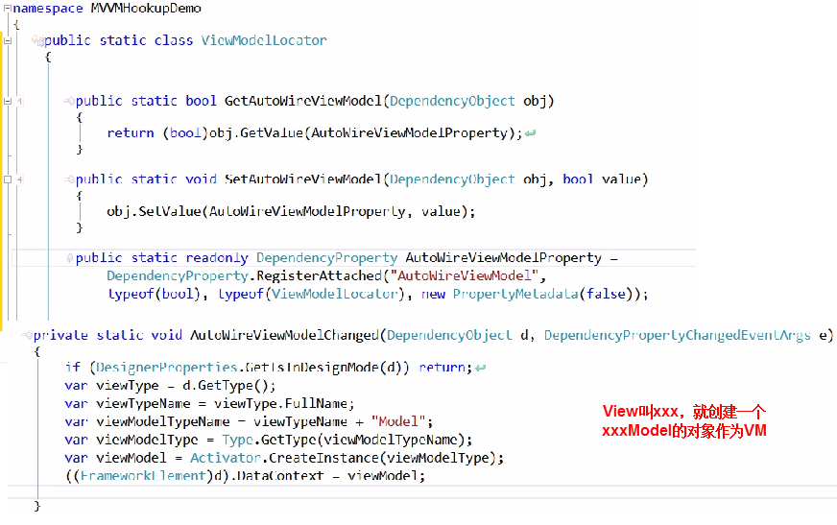

然后在需要使用它的View中设置AutoWireViewModel为true

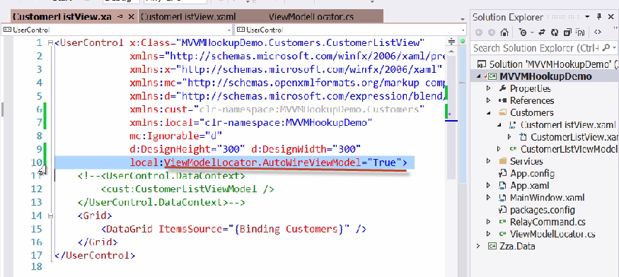

### Data Binding

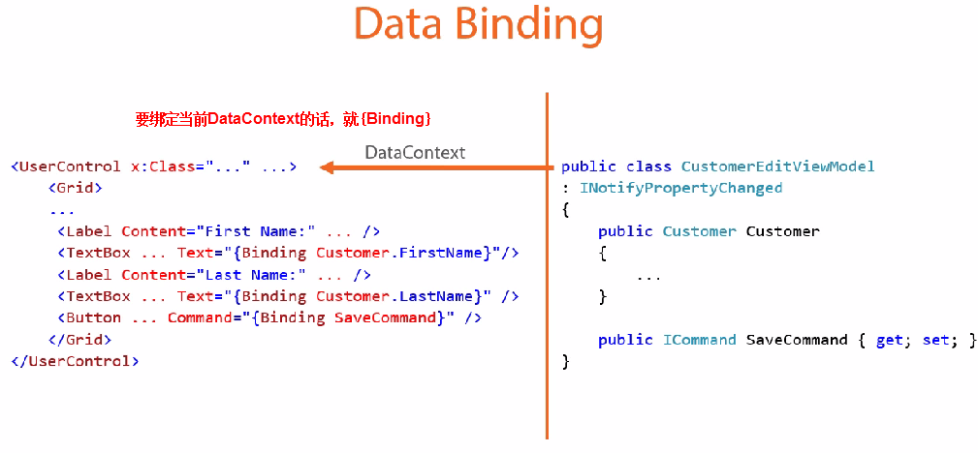

### View Model First——DataTemplate

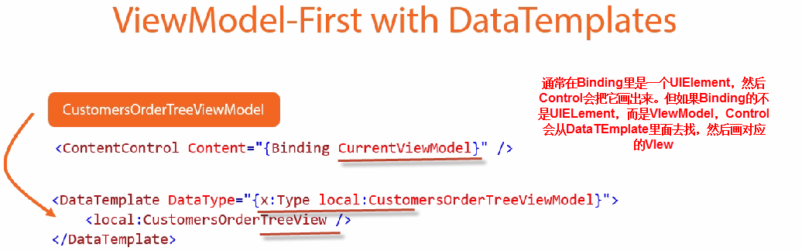

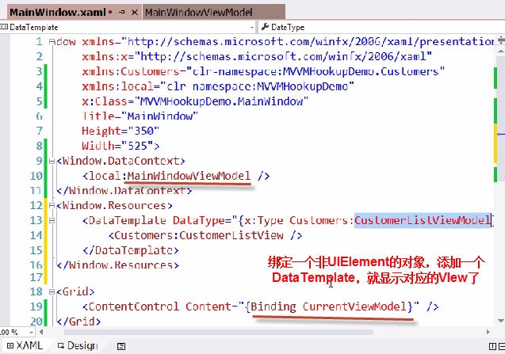

也可以绑定ItemControl

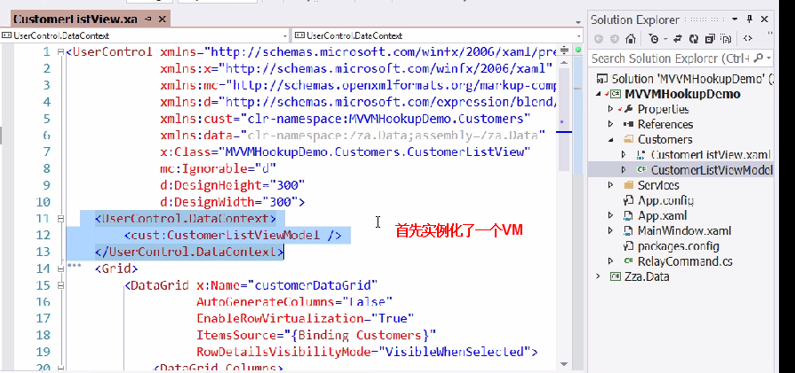

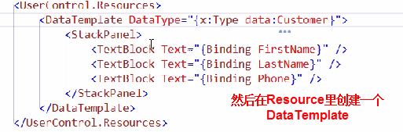

最后在需要使用的地方直接绑定Type是Customer的Model即可

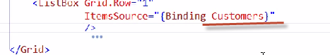

### View VM Communication——Command

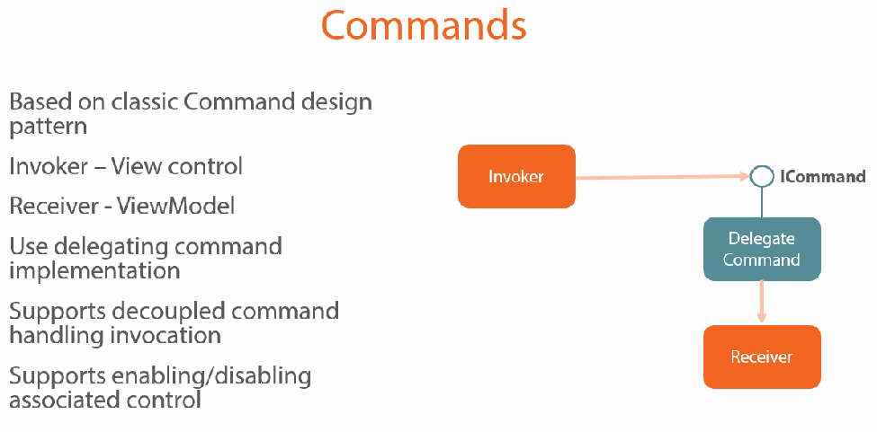

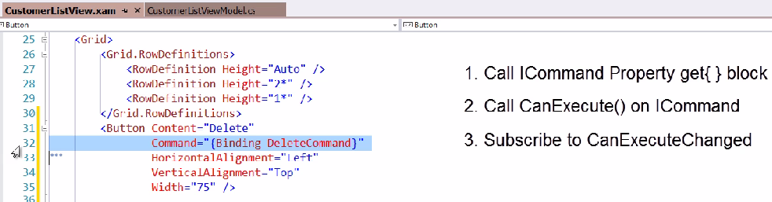

重新判断是否能Execute

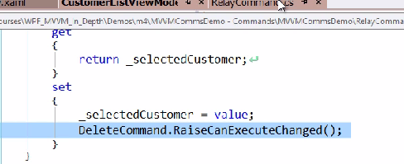

### Input Binding——按键盘与Command

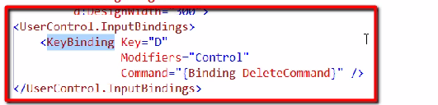

### View VM Communication——Behaviors Attached Properties

首先创建一个Behavior，他有Dependency Property

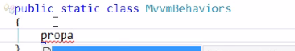

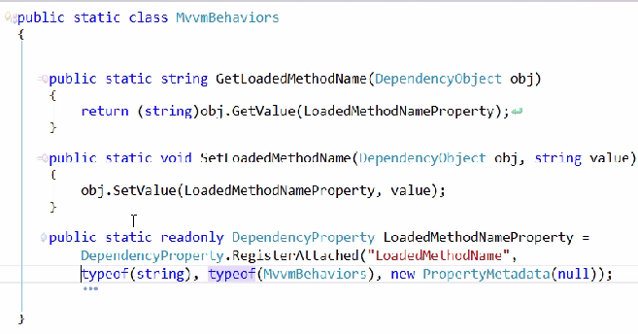

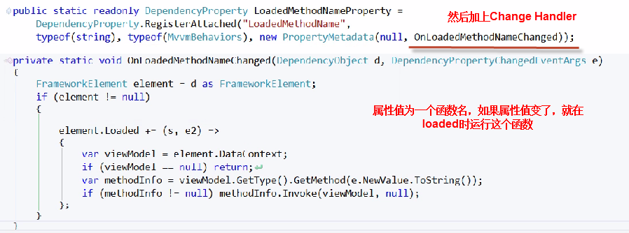

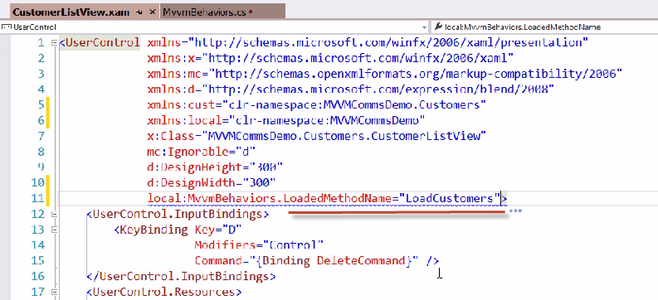

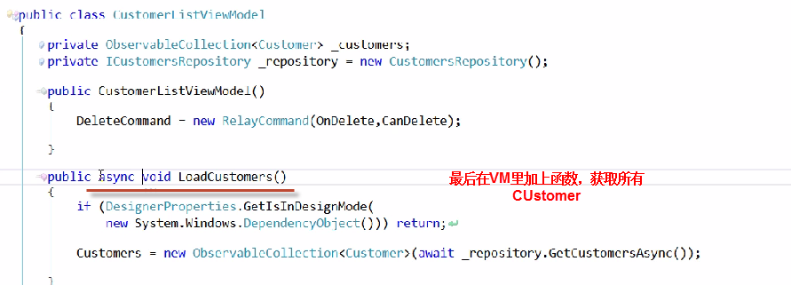

### View VM Communication——Blend Behaviors

在Blend里拖一个CallMethodAction到根元素中

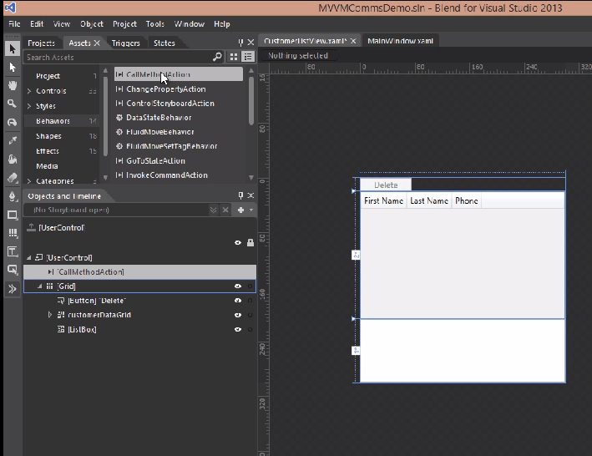

然后回到VS

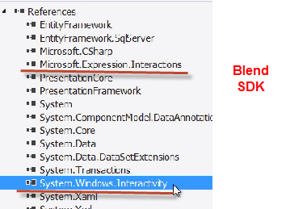

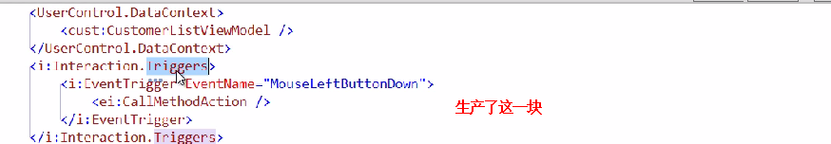

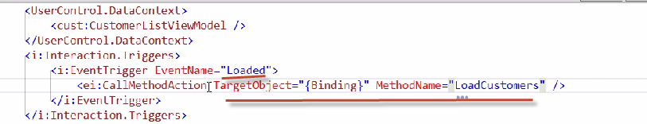

### View VM Communication——Custom Blend Behavior

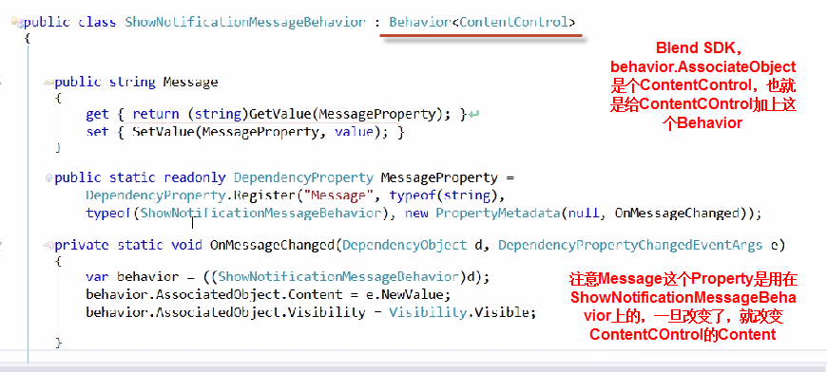

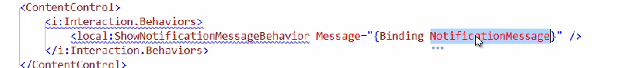

### Hierarchical MVVM——View Switching

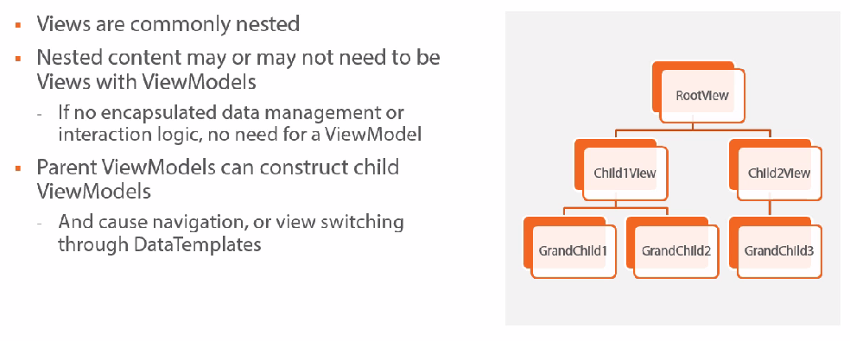

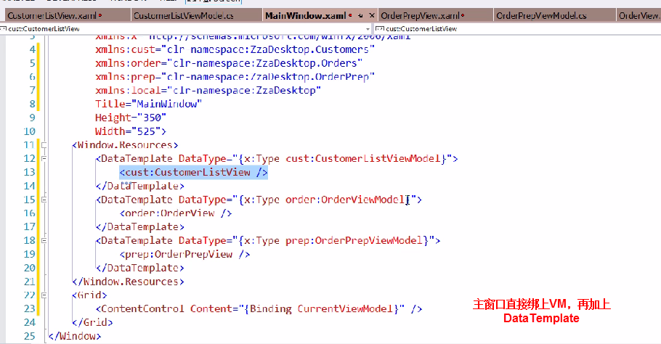

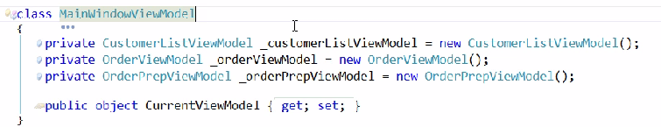

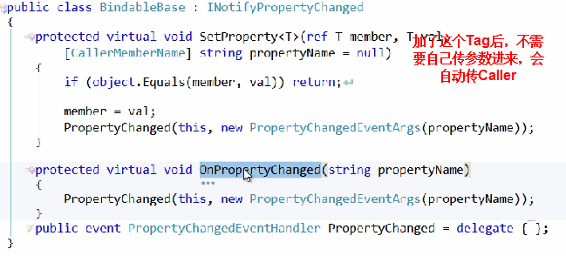

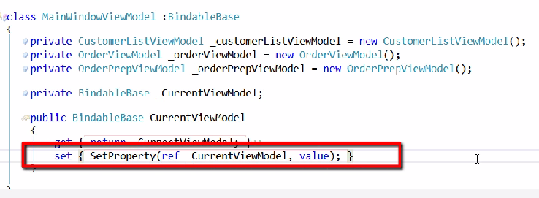

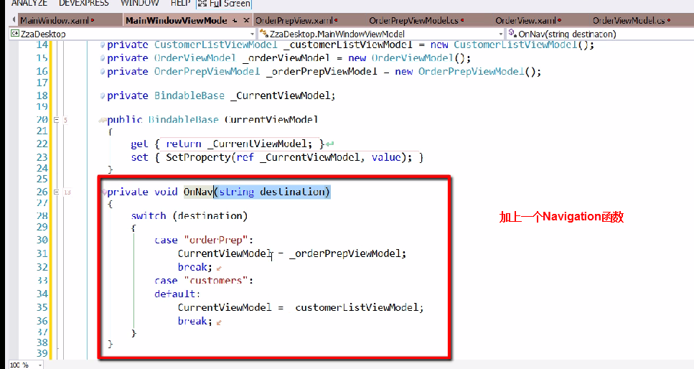

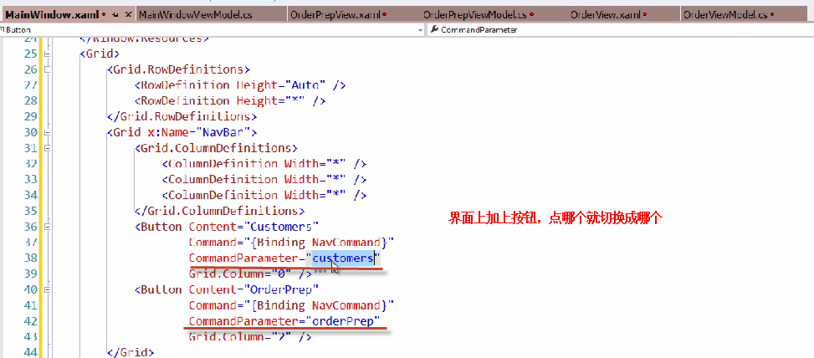

### Data Loading into VM

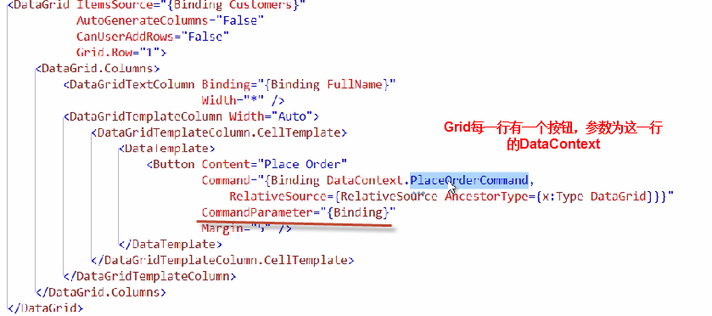

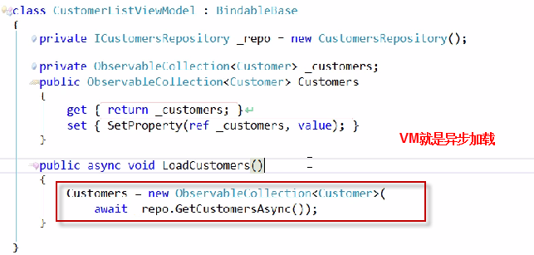

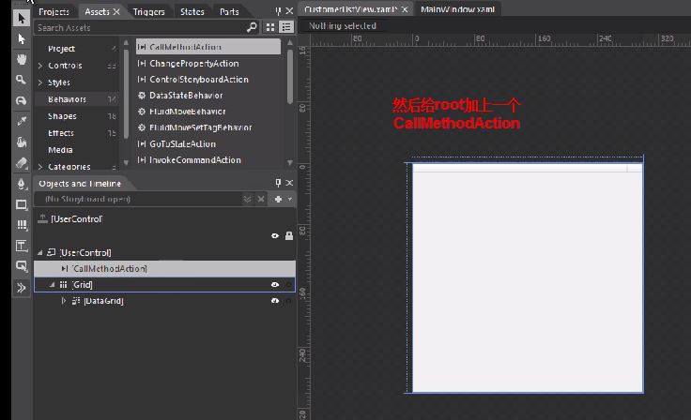

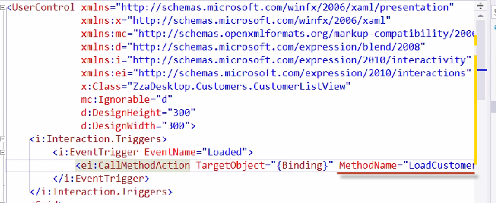

### Navigate to Detail

要实现的是点了某一行的按钮后，显示这一行的信息

Navigate都是通过设置CUrrentViewModel来实现的

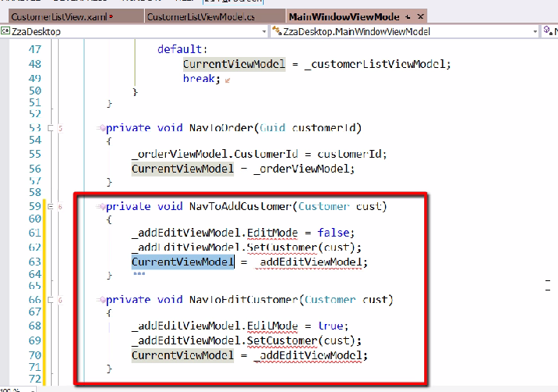

### Data Source Window Code Generation

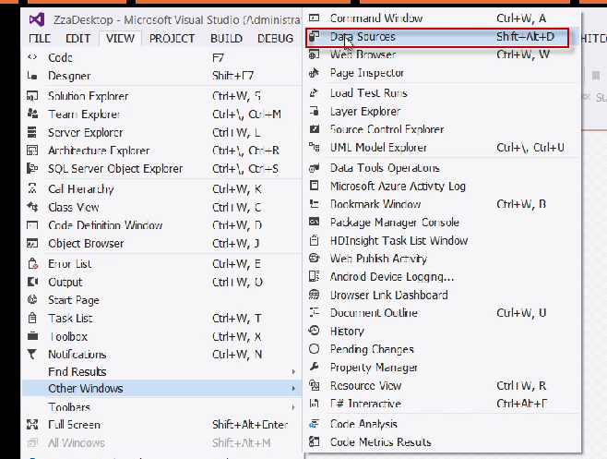

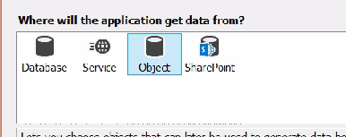

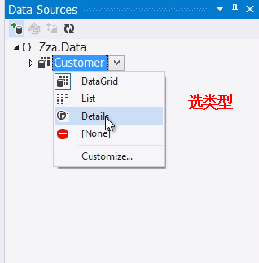

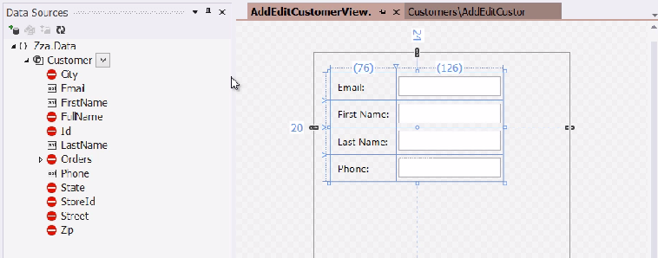

### Edit Nested VM

如果VM1里有一个Customer，在View上改变了CUstormer的某个属性，怎么办

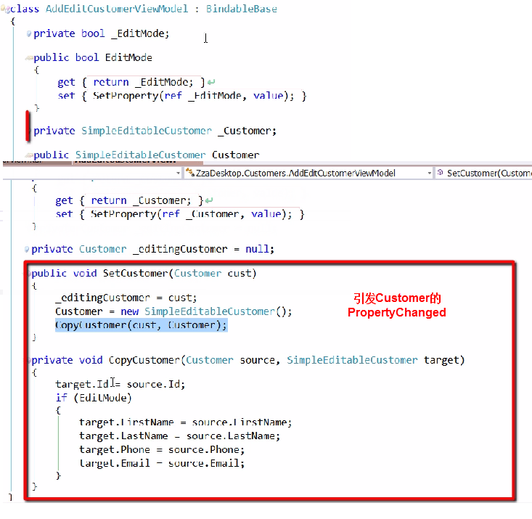

### Validation

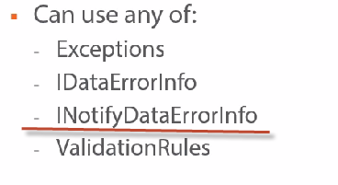

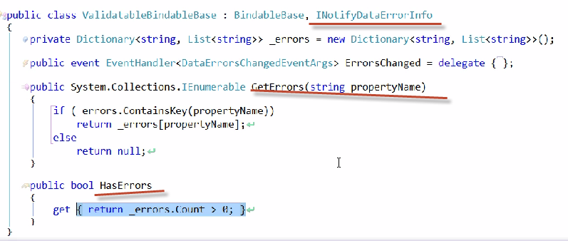

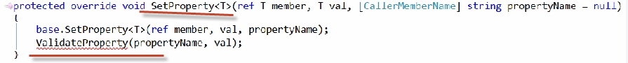

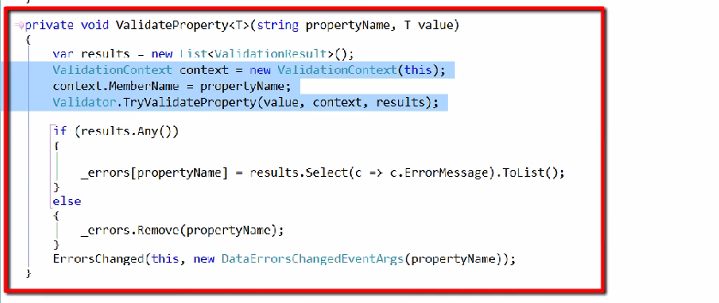

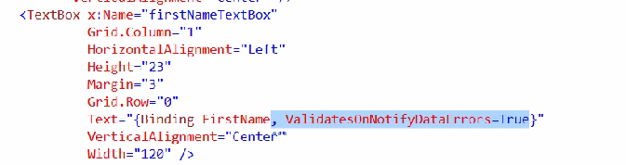

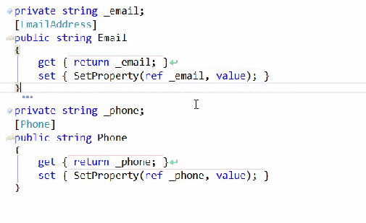

最后添加错误样式

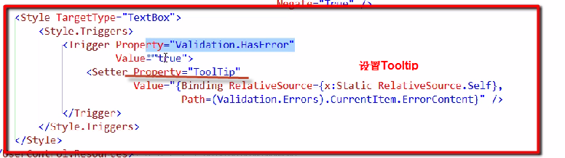

### Dependency Injection——解耦和VM与Service

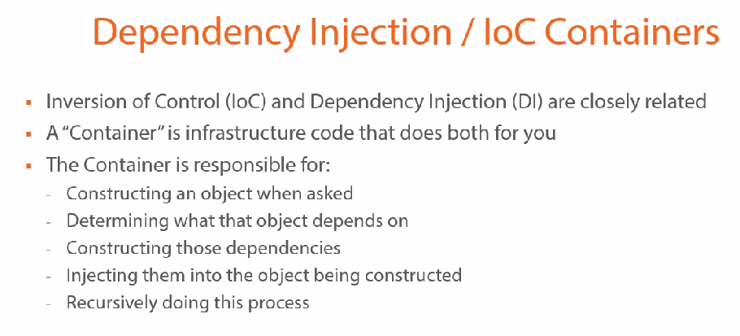

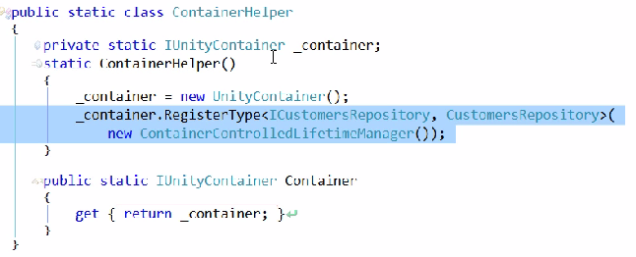

### Search与Filter

